- GENERAL DATA AND INFORMATION:

Panel No : |  | Designation
Make |  | Type | BATTERY ALARM 300
Model | BA31251117A | Range | 125 V_{DC} -20% +40%
Serial No |  | Outputs | 4 C/O Contacts

- MECHANICAL CHECKS AND VISUAL INSPECTION:
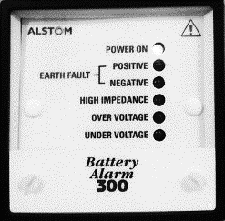
Item | Description | Checked
1 | Inspect for physical damage / defects.
2 | Verify connections as per approved drawings.
3 | Check tightness of all connection.

- ELECTRICAL TEST :

  - RELAY BURDEN :

DC Voltage | Measured Current | Burden
125 V_{DC}

  - SECONDARY INJECTION TEST :

Function | Pick up | Drop off
Under Voltage
Over Voltage

Limits : Accuracy of setting = ± 0.5 %
Hysteresis of setting = ± 0.5 %

  - TIME DELAY TEST (UERGENT ALARM) :

Function | Contact Type | Setting Time | Measured Time
Under Voltage | Urgent | 1 sec
Over Voltage | Urgent | 1 sec

  - HIGH IMPEDANCE ALARM (UERGENT ALARM) :
Apply nominal voltage (125V_{dc}) at 2A rated. Then check high impedance alarm led is OFF.
Connect series resistance with the supply voltage and check high impedance alarm led is
extinguished or not.
If series resistance more than 5 ohm the high impedance alarm led should be ON

Function | Led Indication | Setting Time | Measured Time
R > 5 ohm
R < 5 ohm

  - EARTH FAULT ALARM (NON-UERGENT ALARM) :

Function | Led Indication | Setting Time | Measured Time
Positive + Earth |  | 32 sec
Negative + Earth |  | 32 sec

