This is an example for the Bus Coupler Bay, as per the schematic drawing the contents in this test format can be modified for another Bus coupler

GENERAL DATA AND INFORMATION:

Panel designation
Manufacture

- MECHANICAL CHECKS AND VISUAL INSPECTIONS as Per TCS –P–105 Rev – 01, Item no 4.1

Item | Description | Checked
1 | Inspect for physical damage / defects Check tightness of all connections | Yes | N/A
2 | Check tightness of all connections | Yes | N/A
3 | Panel condition, cleanliness, organization, labeling, readiness for service, panel doors, handles...etc | Yes | N/A
4 | CT shorting and CT, VT isolating checked | Yes | N/A
5 | Indications checked | Yes | N/A
6 | Check the ferrules as per specification | Yes | N/A
7 | Confirm that each panel has been properly secured to the floor in its final service location. | Yes | N/A
8 | Panel Earthing checked | Yes | N/A
9 | Confirm that panels are constructed and wired as per SEC relevant specification. | Yes | N/A
10 | Check case cover and gasket for proper seal against dust. | Yes | N/A
11 | Check all installed equipment nameplate information for compliance to approved drawings and equipment /material lists. | Yes | N/A
12 | For all internal and external panel wiring, confirm that all screw terminations are tight and that crimp connectors are firmly secured to the wire and to the termination point. Ensure that no part of the wire is bent at the termination point. | Yes | N/A
13 | Check that panel equipment is mounted securely and protected against mal operation due to vibration, shock, etc | Yes | N/A
14 | Use of ring type terminals for wire termination for current circuit wires. | Yes | N/A
15 | Disconnectors Manual operation by handle and related interlocking conditions to be checked | Yes | N/A
16 | Mechanical interlocking between DS & ES to be checked | Yes | N/A

- ELECTRICAL TESTS:

Item | Description | Checked
1 | Insulation Resistance Test report of all wires to be submitted  By the contractor prior witnessing and made available | Yes | N/A
2 | DC Power supply and control checked. | Yes | N/A
3 | AC Power supply and control checked. | Yes | N/A
4 | All CB’S, DSW’s and ESW’s should be tested before starting function check | Yes | N/A
5 | Circuit Breaker, Disconnectors and Earth Switch Open/Close status checked | Yes | N/A

- CIRCUIT BREAKER CLOSING / TRIPPING BLOCKING CONDITIONS:

Item | Description | Setting  Values | CB blocked status |  | Remarks
 |  |  | Closing | Tripping
 | SF6 Gas pressure 1st stage
 | SF6 Gas Pressure 2nd Stage
 | CB spring charged condition
 | Anti-Pumping condition

- SINGLE LINE DIAGRAM FOR TEST BAY
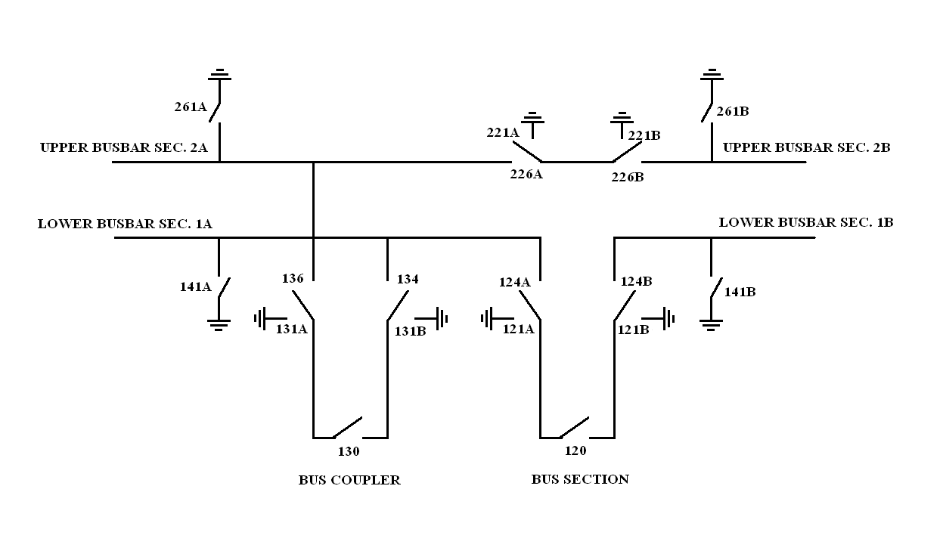

- CHECKING OF OPERATION AND INDICATIONS

Equip.  ref | Command | Operation |  |  | Indication |  |  | Condition | Remarks
 |  | LCC | CR | ECC (FMK) | LCC | CR | ECC (FMK)
134 | Open/  Close |  |  |  |  |  |  | Service
 |  |  |  |  |  |  |  | Test
136 |  |  |  |  |  |  |  | Service
 |  |  |  |  |  |  |  | Test
130 | Close |  |  |  |  |  |  | Service
 |  |  |  |  |  |  |  | Test
 | Open |  |  |  |  |  |  | Service
 |  |  |  |  |  |  |  | Test
131A | Open/ close
131B

- FUNCTIONAL AND INTERLOCKING TEST FOR CIRCUIT BREAKER 130

Operation | Condition | Equipments | Status | Remarks
Close/open | Test | Ds 134 & 136 | Fo
Close* | Service | DS 134 & 136 | FC
Trip | Test & Service | Protection Relays | Operated | As Per Sch Dwg

All checked under normal sf6 gas pressure operating conditions
*Protection Relays Reset, Bus VT Mcb on & Synchronizing condition ok
Note:
FO: Fully Open FC: Fully Close

- FUNCTIONAL TEST FOR C.B TRIP & OPEN BLOCKING:

C.B Open Blocking while load transfer in one feeder or more to be connected to two bus bars which coupled by this bus coupler (130) or load transfer in one feeder or more to be connected to another two bus bars which coupled by bus section and this bus coupler (130).

- FUNCTIONAL AND INTERLOCKING TEST FOR BUS DISCONNECTOR 134:

Operation | Condition | Equipments | Status | Remarks
Close/open | Test | ES 131A & 141A  131B | FC  FO
Close/open | Service | CB130  ES 131A, 131B & 141A | O  FO

Note: FO: fully open FC: fully close O: open

- FUNCTIONAL AND INTERLOCKING TEST FOR BUS DISCONNECTOR 136

Operation | Condition | Equipments | Status | Remarks
Close/open | Test | ES 131B & 261A  131A | FC  FO
Close/open | Service | CB130  ES 131A, 131B & 261A | O  FO

Note: FO: fully open FC: fully close O: open

- FUNCTIONAL AND INTERLOCKING TEST FOR EARTH-SWITCH 131A

Operation | Condition | Equipments | Status | Remarks
Close/open | ------- | DS 134 & 136 | FO

Note: FO: fully open

- FUNCTIONAL AND INTERLOCKING TEST FOR EARTH-SWITCH 131B

Operation | Condition | Equipments | Status | Remarks
Close/open | ------------ | DS 134 & 136 | FO

Note: FO: fully open

- CHECKING OF INDICATIONS

As per the schematic drawings

Sl. No. | Events | Command | LCC |  | CR |  | FMK
 |  |  | TB No. | Status | TB No. | Status | TB No. | Status
 |  |  |  | [ ] |  | [ ] |  | [ ]
 |  |  |  | [ ] |  | [ ] |  | [ ]
 |  |  |  | [ ] |  | [ ] |  | [ ]
 |  |  |  | [ ] |  | [ ] |  | [ ]
 |  |  |  | [ ] |  | [ ] |  | [ ]
 |  |  |  | [ ] |  | [ ] |  | [ ]
 |  |  |  | [ ] |  | [ ] |  | [ ]
 |  |  |  | [ ] |  | [ ] |  | [ ]
 |  |  |  | [ ] |  | [ ] |  | [ ]
 |  |  |  | [ ] |  | [ ] |  | [ ]
 |  |  |  | [ ] |  | [ ] |  | [ ]
 |  |  |  | [ ] |  | [ ] |  | [ ]
 |  |  |  | [ ] |  | [ ] |  | [ ]
 |  |  |  | [ ] |  | [ ] |  | [ ]
 |  |  |  | [ ] |  | [ ] |  | [ ]
 |  |  |  | [ ] |  | [ ] |  | [ ]
 |  |  |  | [ ] |  | [ ] |  | [ ]

- CHECKING OF LCC ANNUN, INDICATION & ALARMS: (ANNUNCIATOR-1)

Channel no. | Events | LCC |  | CR |  | Status
 |  | TB no | Status | TB no | Status
 |  |  |  |  |  | [ ]
 |  |  |  |  |  | [ ]
 |  |  |  |  |  | [ ]
 |  |  |  |  |  | [ ]
 |  |  |  |  |  | [ ]
 |  |  |  |  |  | [ ]
 |  |  |  |  |  | [ ]
 |  |  |  |  |  | [ ]
 |  |  |  |  |  | [ ]
 |  |  |  |  |  | [ ]
 |  |  |  |  |  | [ ]

- CHECKING OF LCC ANNUN, INDICATION & ALARMS :( ANNUNCIATOR-2)

Channel no. | Events | LCC |  | CR |  | Status
 |  | Tb no | Status | Tb no | Status
 |  |  |  |  |  | [ ]
 |  |  |  |  |  | [ ]
 |  |  |  |  |  | [ ]
 |  |  |  |  |  | [ ]
 |  |  |  |  |  | [ ]
 |  |  |  |  |  | [ ]
 |  |  |  |  |  | [ ]
 |  |  |  |  |  | [ ]
 |  |  |  |  |  | [ ]
 |  |  |  |  |  | [ ]
 |  |  |  |  |  | [ ]
 |  |  |  |  |  | [ ]
 |  |  |  |  |  | [ ]
 |  |  |  |  |  | [ ]
 |  |  |  |  |  | [ ]

Note:
All interlock points were checked according to interlocking conditions table
which is Approved by system operation department.

