This is an example for the Bus Coupler Bay, as per the schematic drawing the contents in this test format can be modified for another Bus coupler

GENERAL DATA AND INFORMATION:

Panel designation
Manufacture

- MECHANICAL CHECKS AND VISUAL INSPECTIONS as Per TCS –P–105 Rev – 01, Item no 4.1

Item | Description | Checked
1 | Check tightness of all connections | Yes | N/A
2 | Inspect for physical damage / defects | Yes | N/A
3 | Panel condition, cleanliness, organization, labeling, readiness for service, panel doors, handles...etc | Yes | N/A
4 | CT shorting checked | Yes | N/A
5 | Indications checked | Yes | N/A
6 | Check the ferrules as per specification | Yes | N/A
7 | Panel Earthing checked | Yes | N/A
8 | Confirm that each panel has been properly secured to the floor in its final service location. | Yes | N/A
9 | Confirm that panels are constructed and wired as per SEC relevant specification. | Yes | N/A
10 | Check case cover and gasket for proper seal against dust. | Yes | N/A
11 | Check all installed equipment nameplate information for compliance to approved drawings and equipment /material lists. | Yes | N/A
12 | For all internal and external panel wiring, confirm that all screw terminations are tight and that crimp connectors are firmly secured to the wire and to the termination point. Ensure that no part of the wire is bent at the termination point. Check Ferrules. | Yes | N/A
13 | Check that panel equipment is mounted securely and protected against mal operation due to vibration, shock, etc | Yes | N/A
14 | Use of ring type terminals for wire termination for current circuit wires. | Yes | N/A
15 | Disconnectors Manual operation by handle and related interlocking conditions to be checked | Yes | N/A
16 | Mechanical interlocking between DS & ES to be checked | Yes | N/A

- ELECTRICAL TESTS:

Item | Description | Checked
1 | Insulation Resistance Test report of all wires to be submitted  By the contractor prior witnessing and made available | Yes | N/A
2 | DC Power supply and control checked. | Yes | N/A
3 | AC Power supply and control checked. | Yes | N/A
4 | All CB’S, DSW’s and ESW’s should be tested before starting function check | Yes | N/A
5 | Circuit Breaker, Disconnectors and Earth Switch Open/Close status checked | Yes | N/A

- CIRCUIT BREAKER CLOSING / TRIPPING BLOCKING CONDITIONS:

Item | Description | Setting  Values | CB blocked status |  | Remarks
 |  |  | Closing | Tripping
 | SF6 Gas pressure 1st stage
 | SF6 Gas Pressure 2nd Stage
 | CB spring charged condition
 | Anti-Pumping condition

- SINGLE LINE DIAGRAM FOR TEST BAY
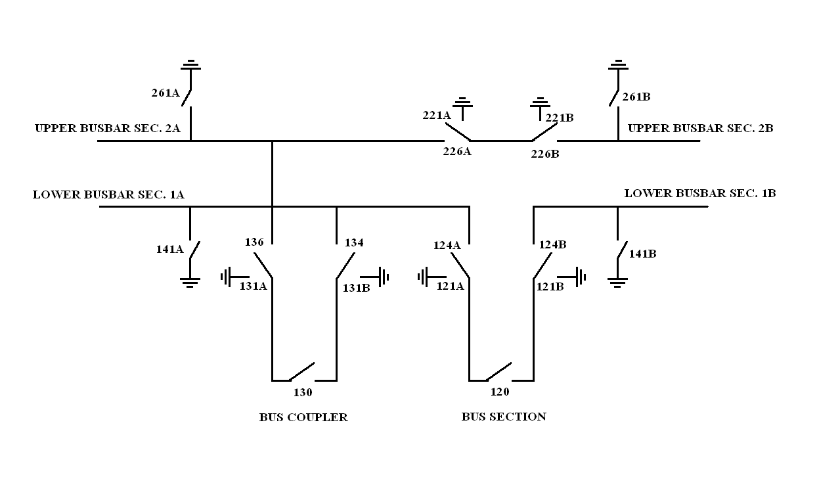

- CHECKING OF OPERATION AND INDICATIONS

Equipment Reference | Command | Operation |  |  | Indication |  |  | Condition | Remarks
 |  | LCC | CR | ECC  (FMK) | LCC | CR | ECC  (FMK)
124A | Open/  Close |  |  |  |  |  |  | Service
 |  |  |  |  |  |  |  | Test
124B |  |  |  |  |  |  |  | Service
 |  |  |  |  |  |  |  | Test
226A |  |  |  |  |  |  |  | Service
 |  |  |  |  |  |  |  | Test
226B |  |  |  |  |  |  |  | Service
 |  |  |  |  |  |  |  | Test
120 | Close |  |  |  |  |  |  | Service
 |  |  |  |  |  |  |  | Test
 | Open
121A | Open/  Close |  |  |  |  |  |  | Independent condition
121B
221A
221B
261A
261B
141A
141B

- FUNCTIONAL AND INTERLOCKING TEST FOR CIRCUIT BREAKER 130

Operation | Condition | Equipments | Status | Remarks
Close* | Test | DS 124A  DS 124B | FO  FO
 | Service | DS 124 A  DS 124 B | FC  FC
Trip | Independent | Protection Relays | Operated | As per the schematic Drawing

All checked under normal sf6 gas pressure operating conditions
*Protection Relays Reset, Bus VT MCB on & Synchronizing condition ok
Note:
FO: Fully Open FC: Fully Close

- FUNCTIONAL TEST FOR C.B TRIP & OPEN BLOCKING:

C.B Open Blocking while load transfer in one feeder or more to be connected to
Two bus bars which coupled by this bus section (120).

- Functional Test for Bus Disconnector 124A:

Operation | Condition | Equipments | Status | Remarks
Close/open | Test | ES – 121B & 141A  ES – 121A | FC  FO
 | Service | ES-121A,121B & 141A  CB -120 | FO  O

Note: FO: fully open FC: fully close O: open C: close

- Functional and Interlocking Test for Bus Disconnector 124B:

Operation | Condition | Equipments | Status | Remarks
Close/open | Test | ES – 121A & 141B  ES – 121B | FC  FO
Close/open | Service | ES-121A ,121B &141B  CB - 120 | FO  O

Note: FO: fully open FC: fully close O: open C: close

- Functional and interlocking test for Bus Disconnector 226A:

Operation | Condition | Equipments | Status | Remarks
Close/open | Test | Es – 221B ,261A  Es – 221A | Fc  Fo
Close/open | Service 1 | Es-221A,221B,261A  Ds- 226B | Fo
Close/open | Service 2 | Es-221A,221B,261A  Ds -206,406,606 & 236 | Fo
Close/open | Service 3 | Es-221A,221B,261A  Ds-106,306,506,706 & 136 | Fo

Note:
FO: fully open FC: fully close

- Functional and Interlocking Test for Bus Disconnector 226B:

Operation | Condition | Equipments | Status | Remarks
Close/open | Test | ES – 221A & 261B  ES – 221B | FC  FO
Close/open | Service 1 | DS-226A,  ES- 221A,221B & 261B | FO
Close/open | Service 2 | ES-221A,221B,261B  DS -206,406,606 & 236 | FO
Close/open | Service 3 | ES-221A,221B,261B  DS-106,306,506,706 & 136 | FO

Note:
FO: fully open FC: fully close

- Functional and interlocking test for Earth Switch 121A:

Operation | Condition | Equipments | Status | Remarks
Close/open | ------------ | DS 124A & 124B | Fo

Note:
FO: fully open

- FUNCTIONAL AND INTERLOCKING TEST FOR EARTH SWITCH 121B:

Operation | Condition | Equipments | Status | Remarks
Close/open | ------------ | Ds 124A & 124B | Fo

Note: FO: fully open

- FUNCTIONAL AND INTERLOCKING TEST FOR EARTH SWITCH 221A:

Operation | Condition | Equipments | Status | Remarks
Close/open | ------------ | Ds – 226A & 226B | Fo

Note: FO: fully open FC: fully close

- FUNCTIONAL AND INTERLOCKING TEST FOR EARTH SWITCH 221B:

Operation | Condition | Equipments | Status | Remarks
Close/open | ------------ | DS – 226A & 226B | FO

Note: FO: fully open FC: fully close

- FUNCTIONAL AND INTERLOCKING TEST FOR EARTH SWITCH 261A:

Operation | Condition | Equipments | Status | Remarks
Close/open | --------- | DS – 226A, 106, 306, 506, 706 & 136 | FO

Note: FO: fully open FC: fully close

- FUNCTIONAL AND INTERLOCKING TEST FOR EARTH SWITCH 261B:

Operation | Condition | equipments | Status | Remarks
Close/open | ------------ | DS– 226B, 206, 406, 606 & 236 | Fo

Note: FO: fully open FC: fully close

- FUNCTIONAL AND INTERLOCKING TEST FOR EARTH SWITCH 141A:

Operation | Condition | Equipments | Status | Remarks
Close/open | ------------ | DS– 124A, 104, 304, 504, 704 &134 | Fo

Note: FO: fully open FC: fully close

- FUNCTIONAL AND INTERLOCKING TEST FOR EARTH SWITCH 141B:

Operation | Condition | Equipments | Status | Remarks
Close/open | ------------ | DS – 124B, 204, 404, 604 & 234 | Fo

Note: FO: fully open FC: fully close

- CHECKING OF INDICATIONS

As per the schematic drawings

Sl. No. | Events | Command | LCC |  | CR |  | FMK
 |  |  | TB No. | Status | TB No. | Status | TB No. | Status
 |  |  |  | [ ] |  | [ ] |  | [ ]
 |  |  |  | [ ] |  | [ ] |  | [ ]
 |  |  |  | [ ] |  | [ ] |  | [ ]
 |  |  |  | [ ] |  | [ ] |  | [ ]
 |  |  |  | [ ] |  | [ ] |  | [ ]
 |  |  |  | [ ] |  | [ ] |  | [ ]
 |  |  |  | [ ] |  | [ ] |  | [ ]
 |  |  |  | [ ] |  | [ ] |  | [ ]
 |  |  |  | [ ] |  | [ ] |  | [ ]
 |  |  |  | [ ] |  | [ ] |  | [ ]
 |  |  |  | [ ] |  | [ ] |  | [ ]
 |  |  |  | [ ] |  | [ ] |  | [ ]
 |  |  |  | [ ] |  | [ ] |  | [ ]
 |  |  |  | [ ] |  | [ ] |  | [ ]
 |  |  |  | [ ] |  | [ ] |  | [ ]
 |  |  |  | [ ] |  | [ ] |  | [ ]
 |  |  |  | [ ] |  | [ ] |  | [ ]

- CHECKING OF LCC ANNUN, INDICATION & ALARMS: (ANNUNCIATOR-1)

Channel no. | Events | LCC |  | CR |  | Status
 |  | TB no | Status | TB no | Status
 |  |  |  |  |  | [ ]
 |  |  |  |  |  | [ ]
 |  |  |  |  |  | [ ]
 |  |  |  |  |  | [ ]
 |  |  |  |  |  | [ ]
 |  |  |  |  |  | [ ]
 |  |  |  |  |  | [ ]
 |  |  |  |  |  | [ ]
 |  |  |  |  |  | [ ]
 |  |  |  |  |  | [ ]
 |  |  |  |  |  | [ ]

- CHECKING OF LCC ANNUN, INDICATION & ALARMS : (ANNUNCIATOR-2)

Channel no. | Events | LCC |  | CR |  | Status
 |  | Tb no | Status | Tb no | Status
 |  |  |  |  |  | [ ]
 |  |  |  |  |  | [ ]
 |  |  |  |  |  | [ ]
 |  |  |  |  |  | [ ]
 |  |  |  |  |  | [ ]
 |  |  |  |  |  | [ ]
 |  |  |  |  |  | [ ]
 |  |  |  |  |  | [ ]
 |  |  |  |  |  | [ ]
 |  |  |  |  |  | [ ]
 |  |  |  |  |  | [ ]
 |  |  |  |  |  | [ ]
 |  |  |  |  |  | [ ]
 |  |  |  |  |  | [ ]
 |  |  |  |  |  | [ ]

Note:
All interlock points were checked according to interlocking conditions table
which is Approved by system operation department.

