Note:

* The approved updated final settings should be applied and printed out from the relay by using the software of the relay.
* The approved final setting and the printout final setting should be attached with this test format.
* The print out final setting should be signed by SEC AND Contractor.
* The following test format contains minimum required tests and some of settings are mentioned as an example and not as limitation.

1. **GENERAL DATA & INFORMATION**

|  |  |  |  |
| --- | --- | --- | --- |
| Panel No. |  | CT Ratio : ______ |  |
| Relay Type |  | In |  |
| Manufacturer |  | VT Ratio |  |
| SERIAL NO |  | Vn |  |
| No. of contacts: |  | Draw. & Sh No. : |  |
| Order - No. |  | Conn.Diag.No. |  |
| Software Version |  | DC. Auxiliary. Voltage |  |
| Opto-coupler supply: |  | Frequency Fn | 60 Hz |

1. **MECHANICAL CHECKS AND VISUAL INSPECTION**

As per TCS –P–105 Rev -1, Item no 4.1& 4.12.1.1

|  |  |  |  |
| --- | --- | --- | --- |
| item | Description | Remarks | |
|  | Inspect for any physical damage or defects. | ❑ Yes | ❑ N/A |
|  | Verify connections and ferrules as per approved drawings | ❑ Yes | ❑ N/A |
|  | Check tightness of all the connections. | ❑ Yes | ❑ N/A |
|  | Check Apparatus List | ❑ Yes | ❑ N/A |
|  | Check relay version and switching elements on printed circuit board | ❑ Yes | ❑ N/A |

1. **ELECTRICAL TESTS**

As per TCS –P–105 Rev -1, Item no 4.2& 4.12.1.2

* 1. **FUNCTION TEST**

|  |  |  |  |
| --- | --- | --- | --- |
| Item | Description | Remarks | |
|  | Human Machine Interface (HMI) Checked. | ❑Yes | ❑N/A |
|  | Case Earthing checked. | ❑Yes | ❑N/A |
|  | LED’s Function Checked. | ❑Yes | ❑N/A |
|  | Trip Contacts Checked. | ❑Yes | ❑N/A |
|  | Reset Function Checked | ❑Yes | ❑N/A |
|  | Group active Functions Checked | ❑Yes | ❑N/A |
|  | Binary inputs checked. | ❑Yes | ❑N/A |
|  | Output Relays Checked | ❑Yes | ❑N/A |
|  | Event Display on HMI Screen Checked | ❑Yes | ❑N/A |
|  | Test switch / plug checked for correct function. | ❑Yes | ❑N/A |
|  | Watchdog contacts checked | ❑Yes | ❑N/A |
|  | Current shorting facility. | ❑Yes | ❑N/A |

* 1. **OPERATING DC SUPPLY CURRENT:**

|  |  |  |  |
| --- | --- | --- | --- |
| DC voltage (V) | DC current w/o fault (mA) | DC current with fault (mA) | Max. calculated watt  (W) |
|  |  |  |  |

Limit: 11W (see technical data manual page 9)

* 1. **INPUT OPTO-ISOLATORS CHECKS** (With Relay Energized):

Test Procedure: Go to Commissioning Test, Test mode (test mode), then go to system data (Opto I/P Status) to check the status of the binary inputs.

|  |  |  |  |
| --- | --- | --- | --- |
| Opto input no. | Test Method  (Energize only one at a time with 125V DC Station Battery voltage) | Result  display 0 to 1 | Remarks |
| OPTO 1 |  |  |  |
| OPTO 2 |  |  |  |
| OPTO 3 |  |  |  |
| OPTO 4 |  |  |  |
| OPTO 5 |  |  |  |
| OPTO 6 |  |  |  |
| OPTO 7 |  |  |  |
| OPTO 8 |  |  |  |
| OPTO 9 |  |  |  |
| OPTO 10 |  |  |  |
| OPTO 11 |  |  |  |
| OPTO 12 |  |  |  |
| OPTO 13 |  |  |  |
| OPTO 14 |  |  |  |
| OPTO 15 |  |  |  |
| OPTO 16 |  |  |  |

* 1. **OUTPUT RELAYS CHECKS** (With Relay Energized):

Test Procedure: Go to Commissioning Test, Test mode (Contacts blocked), Test Pattern mode and select each relay to be tested and Apply Contact Test, after test; apply remove test to de-energize the relay

|  |  |  |  |
| --- | --- | --- | --- |
| Output Relay No. | Test Method  (Energize only one relay at a time by  ‘Contact Test in ‘Apply Test Mode’) | Result  Contact Checked  Res <0.1 Ω | Remarks |
| RL1 |  |  |  |
| RL2 |  |  |  |
| RL3 |  |  |  |
| RL4 |  |  |  |
| RL5 |  |  |  |
| RL6 |  |  |  |
| RL7 |  |  |  |
| RL8 |  |  |  |
| RL9 |  |  |  |
| RL10 |  |  |  |
| RL11 |  |  |  |
| RL12 |  |  |  |
| RL13 |  |  |  |
| RL14 |  |  |  |
| RL15 |  |  |  |
| RL16 |  |  |  |
| RL17 |  |  |  |
| RL18 |  |  |  |
| RL19 |  |  |  |
| RL20 |  |  |  |
| RL21 |  |  |  |

After output relay test; select test mode to be disable.

* 1. **MEASURMENTS CHECK:**

- To check secondary values go to measurement 1.

- To check primary values go to measurement setup, set local values to: primary values, then Go to measurement 1.

* + 1. **CURRENT INPUTS CHECK:**

|  |  |  |  |  |
| --- | --- | --- | --- | --- |
| Input Current | Applied Value | CT Ratio Applied | Displayed Secondary Value  (A) | Displayed Primary Value  (A) |
| IA |  |  |  |  |
| IB |  |  |  |  |
| IC |  |  |  |  |
| IN |  |  |  |  |

The measurement current accuracy of the relay is ± 1 %.

* + 1. **VOLTAGE INPUTS CHECK:**

|  |  |  |  |  |
| --- | --- | --- | --- | --- |
| Input Voltage | Applied Value (V) | VT Ratio Applied | Displayed Secondary Value (V) | Displayed Primary Value (KV) |
| VAB |  |  |  |  |
| VBC |  |  |  |  |
| VCA |  |  |  |  |
| VA |  |  |  |  |
| VB |  |  |  |  |
| VC |  |  |  |  |
| VN |  |  |  |  |

The measurement voltage accuracy of the relay is ± 1 %.

* + 1. **ACTIVE, REACTIVE AND APPARENT POWER CHECK**

- To check the values go to measurement 2. (At Measurement setup check Ref. Voltage and Measure Mode to get correct measured value)

P = V * I * COS (ӨL) and Q = V * I * SIN (ӨL)

|  |  |  |  |  |  |
| --- | --- | --- | --- | --- | --- |
| Phase Angle | Injected Current (A) | Injected Voltage (KV) | Active Power (MW) | Reactive Power (MVAR) | Apparent Power  (MVA) |
|  |  |  |  |  |  |
|  |  |  |  |  |  |
|  |  |  |  |  |  |
|  |  |  |  |  |  |
|  |  |  |  |  |  |

* 1. **SETTING CHECK**

Ensure all the settings are applied for used functions and printout the enclosed setting [ ].

* 1. **DISTANCE FUNCTION CHECK:**
     1. **Impedance Reach Check:**

|  |  |  |
| --- | --- | --- |
| Item | Description | Checked |
| 1 | Print out from FREJA attached |  |

Impedance tolerance: +/- 5% for zone 1 and +/- 10 % for other zones.

|  |  |
| --- | --- |
| Ph-PHPhase – Phase Chars. | Ph-EPhase – Earth Chars. |

PH-E (G):

- Resistive reach: RG =RG Setting / (1+kzn). Ω / phase

- Reactive reach: X = Z* sin (ΦLG). Ω / phase

- Compensation factor KZ = 1/3((Zo-Z1)/Z1).

- Directional line angle: 30 degree.

PH-PH (PH):

- Resistive reach: Rph =RPh Setting / 2 Ω / phase

- Reactive reach: Xph = Z* sin (ΦLG) Ω / phase

- Compensation factor KZ = 1/3((Zo-Z1)/Z1).

- Directional line angle: 30 degree.

* When inject with freja. We must follow that:

- Freja generate Ω / Loop, Relay supply setting Ω / Loop too

- ke = 0 , ke angle = 0 ……… this mean 1 ph fault presented as Ω / loop

- At manual mention to use Ω / phase scheme divide chars. By (1+kz) so at freja which inject per loop we must multiply all PH-E previous equation with (1+Kz) to get correct value)

- At Ph-Ph fault manual mention that, R Limit at relay give as Ω / Loop and Freja multiply generated impedance by factor 2 to get Ω / Loop injection. So we must divide R Limit by factor 2 to get R Limit as Ω / Loop. Which mean Rph Ω / Loop at freja = Rph/2 Ω / Loop at relay

* + 1. **Operating Time Testing:**

|  |  |  |
| --- | --- | --- |
| Item | Description | Checked |
| 1 | Print out from FREJA attached |  |

Time Tolerance:

|  |  |  |  |  |
| --- | --- | --- | --- | --- |
| ZONE | Zone 1 (ms) | Zone 2 (ms) | Zone 3 (ms) | Zone 4(ms) |
| Time tolerance | 13 - 16 ms  (14 ms typical) | T2 +/- (2% or 20 ms) | T3 +/- (2% or 20 ms) | T4 +/- (2% or 20 ms) |

* + 1. **VTS FUNCTION TEST:**

Setting:

VTS time delay =

VTS I2> and Io> inhibit =

Delta I> block =

Threshold for 3p detect =

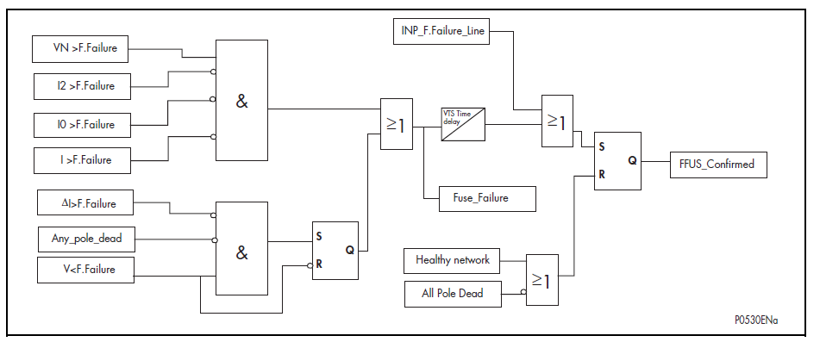

1. Loss of one or two phases test:

Fixed setting = 75% VN (Ures=3Uo = 0.75 * Uph)

-Apply 3 Phase rated voltage (Ur V) with balanced angles.

- Apply 3 Phase rated current (Ir A) with balanced angles.

-for the phase under test start decrease the voltage on one phase and / or two phases till you get internal fuse fail (fuse fail without time lag).

* For time test inject voltage less than Vo.

|  |  |  |  |  |
| --- | --- | --- | --- | --- |
| PHASE | Fixed setting  (Uo=1/3 Ures) volts | Measured value  (Vo) volts | Set Time  (sec) | Measured Time  (sec) |
| R |  |  | . |  |
| Y |  |  |
| B |  |  |
| RY |  |  |
| YB |  |  |
| BR |  |  |

1. Check The Fuse Fail Unblocking BY I2> and Io>

Test Procedure:

* Simulate 3 phase voltage to get fuse Fail.
* Io = 1/3 ( IA + IB + IC ) , Where IA,IB,IC is vectors component
* I2 = 1/3 ( IA + a2 * IB + a * IC ) , where a = 1 L120 , a2 = 1 L240
* for VTS Unblock by Io> inject the rated current on two phases and increase the third phase current From rated current till you get fuse fail removed .
* For VTS Unblock by I2> inject 3ph balanced and but with swap phase Y with phase B angle (ph Y angle = 120, ph B angle = 240) With 1.0 A rated & decrease 3 phase current till you get fuse fail.

- [I2> Unblock measured > mA].

- [Io> Unblock measured> mA].

1. Check the relay unblocking trip during internal fuse fail for Io & I2 [ ].

* Simulate 2 stages:
* Stage 1: inject 3 phase voltage to get fuse fail and zero current.
* Stage 2: inject the same voltage as in stage 1 & inject 3 phase current to get a value greater than Io> inhibit.

1. Testing of 3 phase voltages loss (detect 3p):

Setting range =

|  |  |  |
| --- | --- | --- |
| Set voltage (V) | Applied current per phase(A) | Measured voltage (V) |
|  |  |  |

Test Procedure:

* Apply 3 Phase Voltage as healthy condition.
* Decrease the 3 phase Voltage until VTS Operate.

DELTA I> Test: -

Test Procedure:

* Stage 1 normal case (V=Vr & I=Ir) for the three phase.
* Stage 2 test case (V<U/V on 3phase & current >or≤ ΔI setting) for fuse fail block or fuse fail unblock.

- ΔI Measured= A.

Note: check of ΔI setting should be during one cycle so, use sequence test method.

1. Absence of 3 phases volts on line Energization test:
2. VT MCB input energized (VT MCB OFF), apply 3 phase 1A current with no volts

Apply Fault – Relay Not Trip [ ].

1. VT MCB input not energized (VT MCB ON), apply 3 phase 1A current with no volts

Apply Fault – Relay Trip [ ].

* + 1. **SOTF Test:**

1. Setting:

- Internal dead line detection time (Td) = sec.

- Reset Time (fixed setting) = sec



1. **SOTF enabled by internal detection**

FREJA on manual mode, inject faulty zone directly and take into account the time for dead line detection must be greater than Td

|  |  |  |
| --- | --- | --- |
| SOTF IN | Measured Time(m sec) | Indication |
| Zone 1 |  |  |
| Zone 2 |  |  |
| Zone 3 |  |  |
| Zone 4 |  |  |

1. Td time measurement including the SOTF enabled time = sec.

Test Procedure:

* Use sequence mode; 2 stages: stage 1 normal case (Ur & Ir), stage 2 zero voltage and zero current for time > Td.
* Take contact from signal (SOTF Enable) at PSL.

1. SOTF enabled by input CB Man Close:

* FREJA on auto mode, RX mode, manual, sequence, choose the fault point according to the zone under test, so the waiting time between the pre-fault and faulty page is greater than Td.

|  |  |  |
| --- | --- | --- |
| SOTF IN | Measured Time(m sec) | Indication |
| Zone 1 |  |  |
| Zone 2 |  |  |
| Zone 3 |  |  |
| Zone 4 |  |  |

* + 1. **CHECKING OF COMMUNICATION SCHEME**

SELECTED SCHEME = SET TP =

|  |  |  |  |
| --- | --- | --- | --- |
| SI.NO | DESCRIBTION | | INDICATION |
| 1. | APPLY FAULT IN ZONE-1 = MEASURED TRIP TIME = | | INDICATION = |
| 2. | a. | CHANNEL IN SERVICE AND SIGNAL NOT RECEIVED |  |
|  |  | APPLY FAULT IN ZONE-2 = MEASURED TRIP TIME = | INDICATION = |
|  |  | (THIS TIME IS SUM OF TP + ZONE 2 COMPARATOR TIME) |  |
|  | b. | CHANNEL IN SERVICE AND SIGNAL RECEIVED  APPLY FAULT INZONE-2 = MEASURED TRIP TIME = | INDICATION = |
|  | c. | CHANNEL OUT OF SERVICE AND SGINAL NOT RECEIVED  APPLY FAULT ZONE-2 = MEASURED TRIP TIME = | INDICATION = |
| 3. | APPLY FAULT IN REVERSE ZONE-4 = MEASURED TRIP TIME =  MEASURED CHANNEL SEND TIME = | | INDICATION = |

* + 1. **POWER SWING BLOCKING TEST:**

Setting:

- IN> (% Imax) = %

The residual current threshold value is: IN > [0.1 In + IN> (% Imaxphase) ]

- I2> (%Imax) = %

The negative sequence threshold value is: I2 > [0.1 In + I2> (% Imaxphase)]

- I max line > = * In.

- Unblocking time delay = sec.

1. PSB reach test:

|  |  |  |
| --- | --- | --- |
| Item | Description | Checked |
| 1 | Print out from FREJA attached |  |

The power swing is detected where all three phase –phase measured impedances have taken more than 5 ms to reach the trip characteristic boundary of zone ¾.

1. Measurement of the unblocking time delay = sec.

(Select the PSB contact to dual time)

1. Check the power swing blocking for Zones 1,2,3,4 [ ].

(Use ramp technique to test this function; and by changing the unblocking time delay of the PSB to very small (1 sec) and / or very long (30 sec), then we can control the PSB un-block / block of the different zones trip)

1. Check the relay trip during power swing if an earth fault occurs [ ].

Adjust the PSB unblocking time delay to max value (30 sec), on the same page of FREJA Adjust the 3 Phase voltage to Ur (66.4 V) with balanced angels and the 3 phase current to Ir (1.0 A) with balanced angels; start decreasing the voltage on the 3 phase until you get power swing then change one phase current till relay trip).

1. Check the relay trip during power swing if a phase to phase fault occurs [ ].

(Adjust the PSB unblocking time delay to max value (30 sec), shift the neutral current wire of the test set to blue phase to get pure negative phase sequence, on the same page of FREJA.

Adjust the 3 Phase voltage to Ur (66.4 V) with balanced angels and the 3 phase current to Ir (1.0 A) with 180 degree phase shift between red and yellow phases; start decreasing the voltage on the 3 phase until you gets power swing then change red phase current until you get PSB block)

1. Check the relay trip during power swing if a three phase fault occurs [] And check the max line current (Imax line>) threshold value=

(Adjust the PSB unblocking time delay to max value (30 sec), on the same page of FREJA

Adjust the 3 Phase voltage to Ur (66.4 V) with balanced angels and the 3 phase current to Ir (1.0 A) with balanced angels; start decreasing the voltage on the 3 phase until you get power Swing then change the 3 phase current till relay trips)

(Refer application notes manual for more details)

* + 1. **DELAYED DEF TEST (IN>1)**

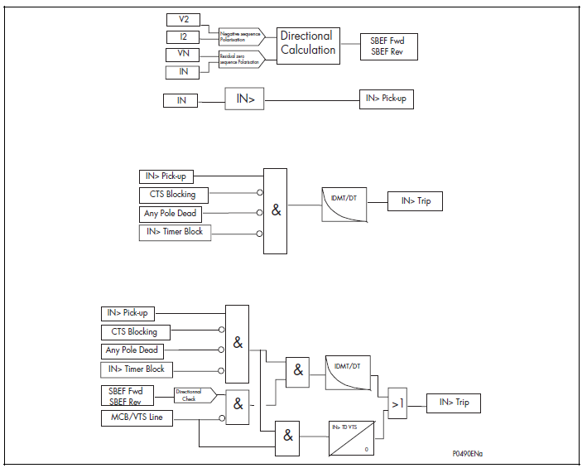

Setting:

* Directional :
* IN>1 current set :
* Time Chars.
* TMS =
  1. **Current Sensitivity Test**

|  |  |  |  |
| --- | --- | --- | --- |
| Current Setting ( A ) | Pickup ( A ) | Drop off ( A ) | Remark |
|  |  |  |  |
|  |  |  |  |
|  |  |  |  |

* 1. **Trip Time Test ( Definite time )**

Inject at (2* I setting)

|  |  |  |
| --- | --- | --- |
| Setting ( sec ) | Measured (sec ) | Remark |
|  |  |  |
|  |  |  |
|  |  |  |

* 1. **Trip Time Test ( IEC standard Inverse )**

TMS =

|  |  |  |
| --- | --- | --- |
| Inject / Current Setting | Time Calculated (sec ) | Time Measured ( sec ) |
|  |  |  |
|  |  |  |
|  |  |  |

* + 1. **Delayed DEF Test (IN>2)**

- Vo

+ Vo

Io

Max. Torque

RCA

Max. Torque Injected from Freja due to + residual component

Forward

Reverse

Setting:

* Directional :
* IN>2 Current Set =
* Time Delay Char. Definite =
* IN Chars. Angle =

Note:

* Relay Compare – Vres with +Ires to get directionality, so direction with +Vres respect to +Ires be as in the above figure.
* Apply 3 Phase Voltage as per the below Table.
* For Phase under Test keep the current Angle 65 Degree (Lag).
* Inject one phase current to the phase under test and keep other two phases with Zero Current.
* Keep AIDED DEF disable.

1. **Current Sensitivity Test**

|  |  |  |  |  |  |
| --- | --- | --- | --- | --- | --- |
| Applied Voltage V | | | Pick-up Current mA | Drop off Current mA | Indication |
| R | Y | B |
| 56.4 ∟0 | 66.4 ∟240 | 66.4 ∟120 | IR=  IY=0  IB=0 | IR=  IY=0  IB=0 |  |
| 66.4 ∟120 | 56.4 ∟0 | 66.4 ∟240 | IR=0  IY=  IB=0 | IR=0  IY=  IB=0 |  |
| 66.4 ∟240 | 66.4 ∟120 | 56.4 ∟0 | IR=0  IY=0  IB= | IR=0  IY=0  IB= |  |

Current accuracy ± 5 %, Voltage accuracy ± 10 % at 90 Degree.

1. **Voltage Sensitivity Test**

|  |  |  |  |  |
| --- | --- | --- | --- | --- |
| Phase | Applied Current A | Minimum operating voltage | | Indication |
| Pick-up | Drop-off |
| R |  |  |  |  |
| Y |  |  |  |  |
| B |  |  |  |  |
| R |  |  |  |  |
| Y |  |  |  |  |
| B |  |  |  |  |
| R |  |  |  |  |
| Y |  |  |  |  |
| B |  |  |  |  |

1. **Trip Time Test:**

|  |  |  |  |  |  |
| --- | --- | --- | --- | --- | --- |
| Applied Voltage V | | | Applied Current mA | Measured Trip Time (sec) | Indication |
| R | Y | B |
| 44 ∟0 | 66.4 ∟240 | 66.4 ∟120 | IR=  IY=0  IB=0 |  |  |
| 66.4 ∟120 | 44 ∟0 | 66.4 ∟240 | IR=0  IY=  IB=0 |  |  |
| 66.4 ∟240 | 66.4 ∟120 | 44 ∟0 | IR=0  IY=0  IB= |  |  |

1. **Directional Test**

|  |  |  |  |  |  |  |  |
| --- | --- | --- | --- | --- | --- | --- | --- |
| Applied Voltage V | | | Applied Current mA | Expected operating angle | Actual operating angle | Direction | Relay status |
| R | Y | B |
| 44 ∟0 | 66.4 ∟240 | 66.4 ∟120 |  | 330-150° |  |  |  |
| 66.4 ∟120 | 44 ∟0 | 66.4 ∟240 |  | 330-150° |  |  |  |
| 66.4 ∟240 | 66.4 ∟120 | 44 ∟0 |  | 330-150° |  |  |  |

Note: To get the Angle, Current Angle be fixed to zero and Change the Voltage angle.

* + 1. **Aided DEF Test (Instantaneous)**

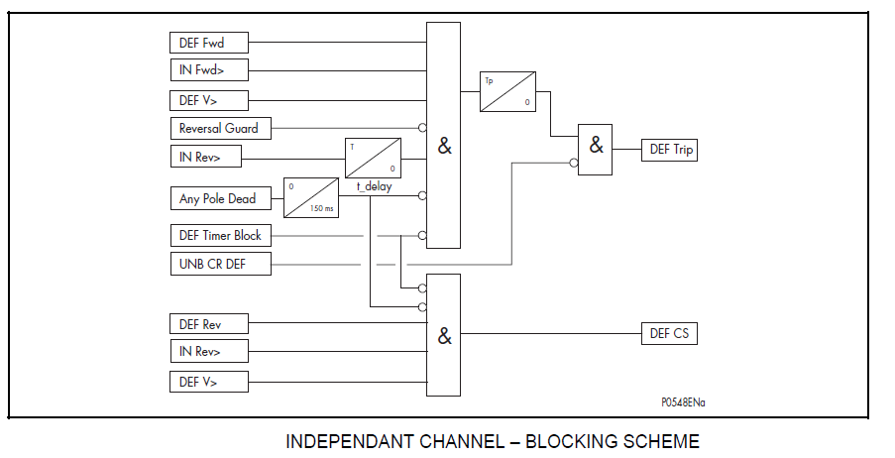

Setting:

* V>= V, IN>= A
* Time Delay = Sec, Aided 2 DEF Delay= ms
* Scheme Logic= Blocking.

Note:

* Apply 3 Phase Voltage as per the below Table.
* For Phase under Test keep the current Angle -60 Degree.
* Inject one phase current to the phase under test and keep other two phases with minimum Current. ( > 0.1 In , to get no Dead Line condition which effect result )
* Keep Channel in Service.

1. **Current Sensitivity Test**

|  |  |  |  |  |  |
| --- | --- | --- | --- | --- | --- |
| Applied Voltage V | | | Pick-up Current mA | Drop off Current mA | Indication |
| R | Y | B |
| 56.4 ∟0 | 66.4 ∟240 | 66.4 ∟120 | IR=  IY=0.2  IB=0.2 | IR=  IY=0.2  IB=0.2 |  |
| 66.4 ∟120 | 56.4 ∟0 | 66.4 ∟240 | IR=0.2  IY=  IB=0.2 | IR=0.2  IY=  IB=0.2 |  |
| 66.4 ∟240 | 66.4 ∟120 | 56.4 ∟0 | IR=0.2  IY=0.2  IB= | IR=0.2  IY=0.2  IB= |  |

1. **Trip Time Test**

|  |  |  |  |  |  |
| --- | --- | --- | --- | --- | --- |
| Applied Voltage V | | | Applied Current mA | Measured Trip Time (sec) | Indication |
| R | Y | B |
| 44 ∟0 | 66.4 ∟240 | 66.4 ∟120 | IR=  IY=0.2  IB=0.2 |  |  |
| 66.4 ∟120 | 44 ∟0 | 66.4 ∟240 | IR=0.2  IY=  IB=0.2 |  |  |
| 66.4 ∟240 | 66.4 ∟120 | 44 ∟0 | IR=0.2  IY=0.2  IB= |  |  |

Note: Measured Trip time = Any Pole Dead time (150 ms) + Tp (70 ms)

1. **Directional Test:**

|  |  |  |  |  |  |  |  |
| --- | --- | --- | --- | --- | --- | --- | --- |
| Applied Voltage V | | | Applied Current mA | Expected operating angle | Actual operating angle | Direction | Relay status |
| R | Y | B |
| 44 ∟0 | 66.4 ∟240 | 66.4 ∟120 |  | 356-166° |  |  |  |
| 66.4 ∟120 | 44 ∟0 | 66.4 ∟240 |  | 356-166° |  |  |  |
| 66.4 ∟240 | 66.4 ∟120 | 44 ∟0 |  | 356-166° |  |  |  |

Note: To get the Angle, Current Angle be fixed to zero and Change the Voltage angle.

1. **Blocking Scheme Test**

1. Channel Send contact Time Test.

* Apply fault in Reverse Direction

|  |  |  |  |  |  |
| --- | --- | --- | --- | --- | --- |
| Applied Voltage V | | | Applied Current mA | CS Time (ms) | Indication |
| R | Y | B |
| 44 ∟0 | 66.4 ∟240 | 66.4 ∟120 | IR=  IY=0  IB=0 |  |  |
| 66.4 ∟120 | 44 ∟0 | 66.4 ∟240 | IR=0  IY=  IB=0 |  |  |
| 66.4 ∟240 | 66.4 ∟120 | 44 ∟0 | IR=0  IY=0  IB= |  |  |

1. DEF Channel Receive Test _________ [ ]

* Apply fault in Forward Direction + CR.
* No Operation for Fast Trip.
* Delayed DEF Operated.

1. DEF Channel Out of Service ________ [ ]

* Apply fault in Forward Direction
* No Operation for Fast Trip.
* Delayed DEF Operated.
  1. **Back-up over current Test I>1:**
     1. **PICK-UP AND DROP-OFF TEST:**

|  |  |  |  |  |  |  |
| --- | --- | --- | --- | --- | --- | --- |
| Current Setting Is | R-Phase | | Y-Phase | | B-Phase | |
| Pick-up | Drop-off | Pick-up | Drop-off | Pick-up | Drop-off |
|  |  |  |  |  |  |  |

DT: ± 2%, IDMT: 1.05 x ± 5%

* + 1. **Time Multiplier Test (All Values Are as Example)**

Time Chars: IEC SI

(Values in sec at 2 time of the setting)

|  |  |  |  |  |  |  |
| --- | --- | --- | --- | --- | --- | --- |
| TMS Value | R-Phase | | Y-Phase | | B-Phase | |
| Calculated | Actual | Calculated | Actual | Calculated | Actual |
| 0.25 | 2.5 |  | 2.5 |  | 2.5 |  |
| 0.3 | 3.0 |  | 3.0 |  | 3.0 |  |
| 0.5 | 5.01 |  | 5.01 |  | 5.01 |  |
| 1.0 | 10.03 |  | 10.03 |  | 10.03 |  |

* + 1. **Timing Test**

|  |  |  |  |  |  |  |  |
| --- | --- | --- | --- | --- | --- | --- | --- |
| Current setting Is | Curve Setting | TMS | Current Setting Is Times | Op. Time Calculated sec | Actual Op. Time sec | | |
| R-Phase | Y-Phase | B-Phase |
| 1*In | IEC SI | 1.0 | 2 | 10.029 |  |  |  |
| 1*In | IEC VI | 1.0 | 5 | 3.375 |  |  |  |
| 1*In | IEC EI | 1.0 | 2 | 26.666 |  |  |  |
| 1*In | LTI | 2.0 | 2 | 12 |  |  |  |
| 1*In | Definit Time | 2.0 | 2 | 2.00 |  |  |  |
| 1*In | Definit Time | 2.0 | 3 | 2.00 |  |  |  |
| 1*In | Definit Time | 2.0 | 5 | 2.00 |  |  |  |

* 1. **SYNCH CHECK TEST**
     1. **Synchro-Check Voltage check**

Fix U1 at normal voltage and change U2.

|  |  |  |  |  |  |  |  |
| --- | --- | --- | --- | --- | --- | --- | --- |
| SETVALUE  U % (V) | APPLIED  VOLTAGE U1 | MEASURED VOLTAGE U2 | | | | | |
| PICK-UP  Voltage (V) | | +U | -U | Errors % | |
| +U | -U | +U % | +U % |
| 6.5 | 66.4 |  |  |  |  |  |  |
| 10.0 | 66.4 |  |  |  |  |  |  |

Fix U2 at normal voltage and change U1.

|  |  |  |  |  |  |  |  |
| --- | --- | --- | --- | --- | --- | --- | --- |
| SETVALUE  U % (V) | APPLIED  VOLTAGE U2 | MEASURED VOLTAGE U1 | | | | | |
| PICK-UP  Voltage (V) | | +U | -U | Errors % | |
| +U | -U | +U % | +U % |
| 6.5 | 66.4 |  |  |  |  |  |  |
| 10.0 | 66.4 |  |  |  |  |  |  |

* + 1. **Synchro-Check Frequency Check**

Fix U1 at normal frequency and change frequency of U2.

|  |  |  |  |  |  |
| --- | --- | --- | --- | --- | --- |
| f (U2) | PICK-UP | | f | | LIMITS |
| +f | - f | +f | -f |
| 50mHz |  |  |  |  | 45 – 50 mHz |

Fix U2 at normal frequency and change frequency of U1.

|  |  |  |  |  |  |
| --- | --- | --- | --- | --- | --- |
| f (U1) | PICK-UP | | f | | LIMITS |
| +f | - f | +f | -f |
| 50mHz |  |  |  |  | 45 – 50 mHz |

* + 1. **Synchro-Check Phase Angle Check**

Fix U1at zero reference phase angle and change phase angle of U2.

|  |  |  |  |  |  |  |
| --- | --- | --- | --- | --- | --- | --- |
| SET  VALUE | ANGLE DIFFERENCE (U2) | | | | Errors % | |
| + Angle | - Angle | + Angle | - Angle | + Angle | - Angle |
| 10 |  |  |  |  |  |  |
| 20 |  |  |  |  |  |  |

Fix U2 at zero reference phase angle and change phase angle of U1.

|  |  |  |  |  |  |  |
| --- | --- | --- | --- | --- | --- | --- |
| SET  VALUE | ANGLE DIFFERENCE (U1) | | | | Errors % | |
| + Angle | - Angle | + Angle | - Angle | + Angle | - Angle |
| 10 |  |  |  |  |  |  |
| 20 |  |  |  |  |  |  |

* + 1. **Voltage Check Function test**

Set U1 =66.4V, U2 =66.4V, f1 and f2 = 60Hz.

LB/DL ________________ [ ]

LL/DB ________________ [ ]

LB/LL ________________ [ ]

* + 1. **VOLTAGE CHECK TEST**

Function: LL/DB

LL =

DB =

Function: DL/LB

DL =

LB =

* 1. **AUTO RECLOSER TEST**
     1. Dead time measurement

|  |  |  |  |  |  |
| --- | --- | --- | --- | --- | --- |
| Dead time 1 sec | | Dead time 2 sec | | Dead time 3 sec | |
| Set time | Meas. time | Set time | Meas. time | Set time | Meas. time |
|  |  |  |  |  |  |
|  |  |  |  |  |  |

* + 1. **Reclaim time measurement**

|  |  |
| --- | --- |
| Set time sec | Measured Time sec |
|  |  |

* 1. **TEST MODE FUNCTIONS TEST**

|  |  |  |  |
| --- | --- | --- | --- |
| Test mode selection function | indications | Relay output with the fault | checked |
|  |  |  |  |
|  |  |  |  |
|  |  |  |  |

* 1. **PROGRAMMABLE LEDS FUNCTIONS TEST**

|  |  |  |
| --- | --- | --- |
| LED no. | Function | Checked |
|  |  |  |
|  |  |  |
|  |  |  |
|  |  |  |

* 1. **DISTURBANCE AND EVENT RECORDER**

- Print out from MICOM S1 [ ]

1. **TEST EQUIPMENTS USED**

|  |  |  |  |  |  |
| --- | --- | --- | --- | --- | --- |
| Item | Description | Make | Equipment Sl .No | Calibration Date | Calibration Due Date |
|  |  |  |  |  |  |
|  |  |  |  |  |  |
|  |  |  |  |  |  |