1. **GENERAL DATA & INFORMATION**

|  |  |  |  |  |
| --- | --- | --- | --- | --- |
| **Bay No.** |  |  | Bay Name |  |
| **Relay designation** | **LINE DIFF.** |  | Model No. | 0411L1x6x1C7CCxH5C424xx |
| **Make** |  |  | S. No. |  |
| **Rated Current** | **1A** |  | **Rated Voltage** | **66.4 V L-N AC** |
| **Frequency** | **50/60 HZ** |  |
| **Logic inputs** | **125VDC** |  | **Aux. Voltage** | **125/250V AC/DC** |
| **Comm. Interface**  **CH-X** | **IEEEC37.94,**  **850nm Fiber** |  | **Comm. Interface**  **CH-Y** | **IEEEC37.94,**  **850nm Fiber** |

1. **MECHANICAL CHECKS AND VISUAL INSPECTION**

|  |  |  |
| --- | --- | --- |
| **Sl.no** | **General checks** | **Status** |
| 1. | Inspect for no physical damage. |  |
| 2. | Verify the wiring connection as per approved drawing. |  |
| 3. | Relay case connected to a local earth bar. |  |
| 4. | Power up the relay circuit and check relay is healthy. |  |
| 5. | Set the relay internal clock. |  |
| 6. | Send the relay setting configuration file to relay through Port F. |  |

### **WATCHDOG RELAY CHECK:**

Check status of watchdog contacts as below.

|  |  |  |  |
| --- | --- | --- | --- |
| OUTPUT | Contact Status | | Remarks |
| Relay De- energized | Relay Energized |
| ALARM C28-C29 | CLOSE | OPEN |  |

### **RELAY DC BURDEN CHECK:**

|  |  |  |  |  |
| --- | --- | --- | --- | --- |
| Relay Status | V Aux Applied(V) | I Measured (mA) | Expected Watts | Calculated Watts |
| Enabled | 125 |  | <25W |  |
| Enabled & Trip | 125 |  | <25W |  |

### **CONTROL INPUT CHECK:**

This is to verify the healthiness of the DC control inputs.

**Apply a rated voltage at each input and verify the status of the input at Front panel or 5025 HMI.**

**Note:**

* **Open 5025 HMI view after the relay is connected to PC.**
* **Open “Device Overview” page and observe the Inputs status.**

**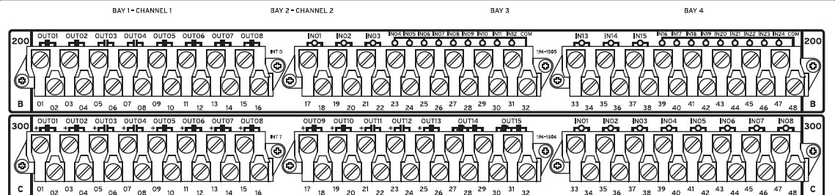**

|  |  |  |
| --- | --- | --- |
| Control input No. | Configuration | Result |
| IN201 |  |  |
| IN202 |  |  |
| IN203 |  |  |
| IN204 |  |  |
| IN205 |  |  |
| IN206 |  |  |
| IN207 |  |  |
| IN208 |  |  |
| IN209 |  |  |
| IN210 |  |  |
| IN211 |  |  |
| IN212 |  |  |
| IN213 |  |  |
| IN214 |  |  |
| IN215 |  |  |
| IN216 |  |  |
| IN217 |  |  |
| IN218 |  |  |
| IN219 |  |  |
| IN220 |  |  |
| IN221 |  |  |
| IN222 |  |  |
| IN223 |  |  |
| IN224 |  |  |
| IN301 |  |  |
| IN302 |  |  |
| IN303 |  |  |
| IN304 |  |  |
| IN305 |  |  |
| IN306 |  |  |
| IN307 |  |  |
| IN308 |  |  |

### **CONTROL OUTPUT RELAY CHECK:**

This is to verify the healthiness of the Control output relay healthiness.

Operate each output through front panel or 5025 HMI, the check continuity of the contact that closes.

* For PULSE the relay outputs, “Breaker” jumper “JMP18-C” shall be put ON position. The jumper “JMP18-C” is available in main board, which is on the top. Open the relay front cover, and change the jumper to ON position on main board, as mentioned in instruction manual section2, page 852.
* **Open 5025 HMI view after the relay is connected to PC.**
* **Open “Control Window” page and Select the OUTPUT that you want to PULSE and select the duration of the PULSE.**
* **Execute the PULSE command. Verify the physical contact close of the corresponding output.**

|  |  |  |
| --- | --- | --- |
| Output Relay No. | Configuration | Result |
| OUT201 |  |  |
| OUT202 |  |  |
| OUT203 |  |  |
| OUT204 |  |  |
| OUT205 |  |  |
| OUT206 |  |  |
| OUT207 |  |  |
| OUT208 |  |  |
| OUT301 |  |  |
| OUT302 |  |  |
| OUT303 |  |  |
| OUT304 |  |  |
| OUT305 |  |  |
| OUT306 |  |  |
| OUT307 |  |  |
| OUT308 |  |  |
| OUT309 |  |  |
| OUT310 |  |  |
| OUT311 |  |  |
| OUT312 |  |  |
| OUT313 |  |  |
| OUT314 |  |  |
| OUT315 |  |  |

### **SINGLE END INJECTION (LOCAL):**

The complete 87L relaying scheme requires pair of two relays one at each end for testing. The following tests in this section “SINGLE END INJECTION” are conducted with relay 87L channels are put in LOOPBACK Mode. These tests prove the relay healthiness, setting sensitivity, input and output configuration. However the complete relaying scheme shall be tested and recorded under section “END-TO-END” test.

**NOTE:**

* 87L function test requires, both local relay and remote relay connected with 87L communication interface and both are powered up. Also it requires current injection at local and remote end with time synchronized test operation.
* Single end current injection allows us to test only 87L sensitivity test. So, the sensitivity test only being performed and that is sufficient to verify the 87L setting.

### **CT/VT INPUT CHECK:**

Note: This test is intended to verify the CT/VT inputs, measurement and CTR, VTR setting in the local relay.

Step1: Apply rated voltage and current to the relay CT/VT inputs.

Step2: Measure the current/voltage at relay HMI or from 5025HMI.

Note:

* Open 5025 HMI view after connecting to the relay.
* Click “Local Instantaneous metering” view and save the snapshot in to annexure word document.
* Click “phasor” view and save the snapshot in to annexure word document.

Find the “Report annexure section.2” for relay Measurement report.

Voltage Applied: 3PH, 115V AC Current applied: 3PH, 1.0A

PTR: 380KV/115V CTR: 3000/1A

CURRENT MEASUREMENT:

|  |  |  |  |  |  |  |
| --- | --- | --- | --- | --- | --- | --- |
| Local | PHASE A MAG/ ANG | PHASE B MAG/ ANG | PHASE C MAG/ ANG | 3I0  MAG/ ANG | 3I2  MAG/ ANG | I1  MAG/ ANG |
| Expected |  |  |  |  |  |  |
| Actual |  |  |  |  |  |  |

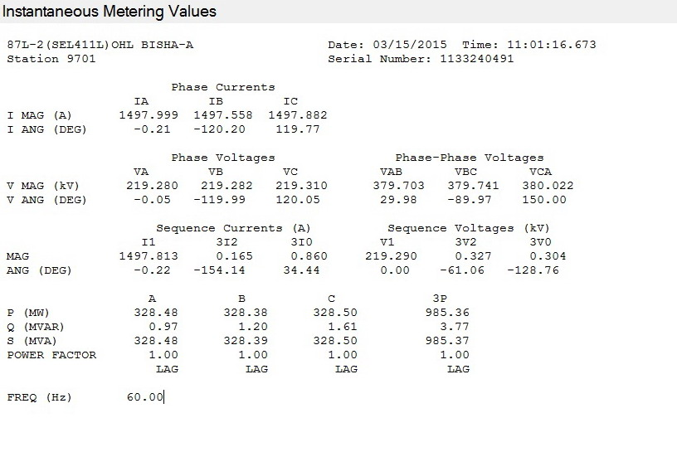

|  |  |  |  |  |  |  |  |
| --- | --- | --- | --- | --- | --- | --- | --- |
| Local | PHASE A MAG/ ANG | PHASE B MAG/ ANG | PHASE C MAG/ ANG | 3I0  MAG/ ANG | | 3I2  MAG/ ANG | I1  MAG/ ANG |
| Expected |  |  |  | |  |  |  |
| Actual |  |  |  | |  |  |  |

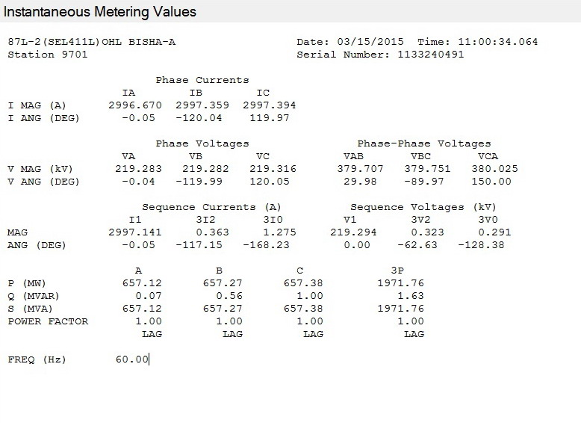

|  |  |  |  |  |  |  |  |
| --- | --- | --- | --- | --- | --- | --- | --- |
| Local | PHASE A MAG/ ANG | PHASE B MAG/ ANG | PHASE C MAG/ ANG | 3I0  MAG/ ANG | | 3I2  MAG/ ANG | I1  MAG/ ANG |
| Expected |  |  |  | |  |  |  |
| Actual |  |  |  | |  |  |  |

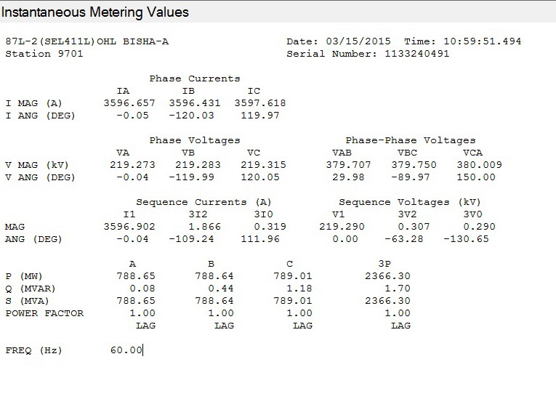

1. **VOLTAGE MEASUREMENT:**

|  |  |  |  |
| --- | --- | --- | --- |
| Local | PHASE AN MAG/ ANG | PHASE BN MAG/ ANG | PHASE CN MAG/ ANG |
| Expected |  |  |  |
| Actual |  |  |  |

### 4

|  |  |  |  |
| --- | --- | --- | --- |
| Local | PHASE AN MAG/ ANG | PHASE BN MAG/ ANG | PHASE CN MAG/ ANG |
| Expected |  |  |  |
| Actual |  |  |  |

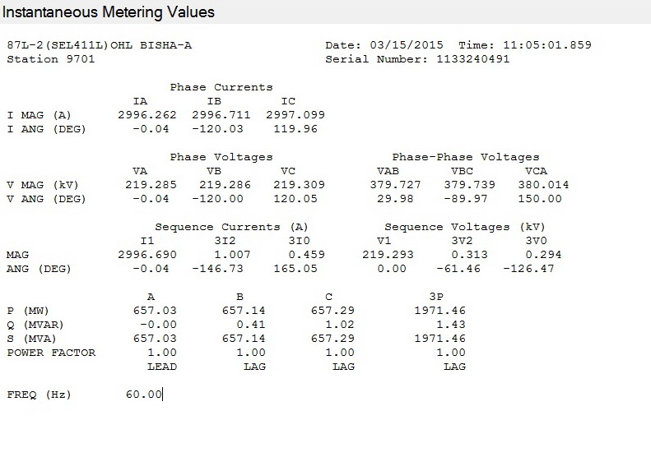

|  |  |  |  |
| --- | --- | --- | --- |
| Local | PHASE AN MAG/ ANG | PHASE BN MAG/ ANG | PHASE CN MAG/ ANG |
| Expected |  |  |  |
| Actual |  |  |  |

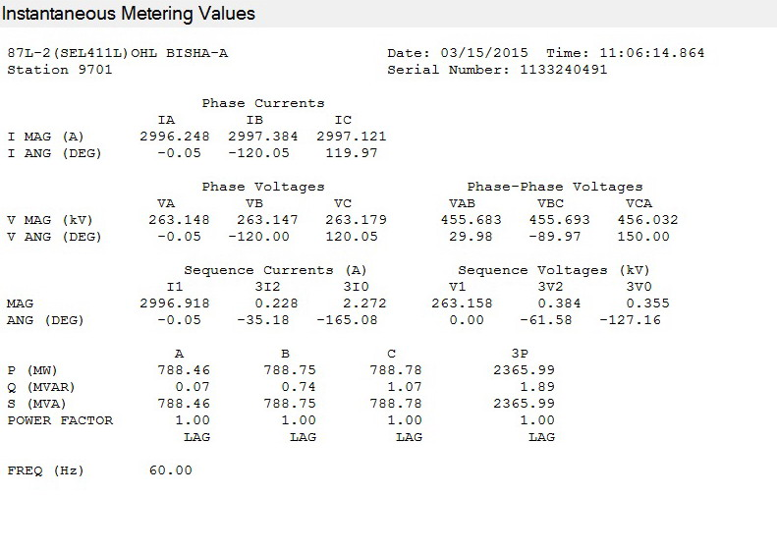

1. **POWER MEASUREMENT:**

Current phase angle = -45deg

|  |  |  |  |
| --- | --- | --- | --- |
| Local | MW | MVAR | PF |
| Expected |  |  |  |
| Actual |  |  |  |

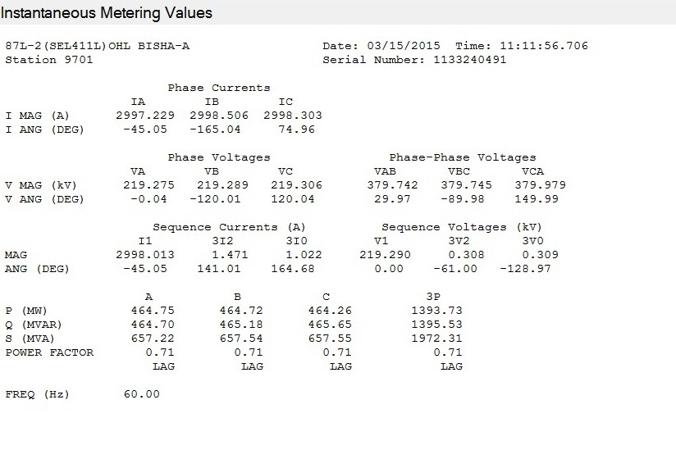

### **ACCURACY:** according to the catalogue page 59

### SnapShot_080207

### **87L DIFFERENTIAL PROTECTION:**

OPERATING PRINCIPLE:

The 87L protection function outputs trip when the following conditions (A & B) are met.

1. The differential current (vector sum magnitude) is greater than minimum threshold (87LPP/ 87L2P/87LGP).
2. The Alpha value is not in the Restraining Region on the alpha plane (OR) the Restraining criterion is disabled.

Note: The Restraining criterion is disabled until the relay finds more than 5%Inom both remote and local current.

### **MEASUREMENT OF CURRENT:**

LOOPBACK TEST MODE:

The second option in the test mode is the loopback test. The 87L Test command can be used to facilitate loopback testing of communications channels to avoid the problem with a communications channel. When the loopback test is active, the relay substitutes the address of the remote relay with its own address in order to allow the 87L element to respond to the data transmitted by it.

**To activate the Loop Back mode:**

The comm. Channel 1 or2 shall be put LOOP BACK mode with following procedure.

* Connect PC to relay using 5030.
* Open “terminal “View”. Enter level 2.
* Type **TEST 87L** command as below to put CH1 or CH 2 in Test loopback.
* The fiber cable must be connected on the relay (between Tx to Rx) to the channel which we need to put in test loopback.

It isn’t allowed to put Ch 1 and Ch 2 in loopback in same time

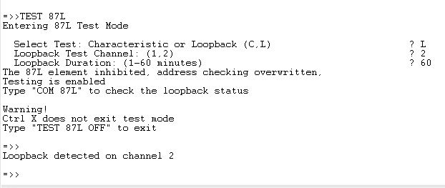

Current applied: 3PH, 1A

PTR: 380KV/115V CTR: 3000/1A

**CURRENT MEASUREMENT WITH ONLY CH 1:**

|  |  |  |  |  |  |  |  |
| --- | --- | --- | --- | --- | --- | --- | --- |
|  | PHASE A MAG/ ANG | PHASE B MAG/ ANG | PHASE C MAG/ ANG | 3I0  MAG/ ANG | | 3I2  MAG/ ANG | I1  MAG/ ANG |
| LOCAL | 0.998<-0.01 | 0.998<-120 | 0.999<120 | | 0.001<157.9 | 0.001<-137 | 0.999<0 |
| CHANNEL 1 | 0.998<-0.02 | 0.998<-120 | 1<119.94 | | 0.003<109 | 0.002<-134 | 0.998<-0.04 |
| Differential | 1.998<-0.02 | 1.998<-120 | 1.998<119.9 | | - | - | - |
| Alpha | 1<180 | 1<180 | 1<180 | | - | - | - |

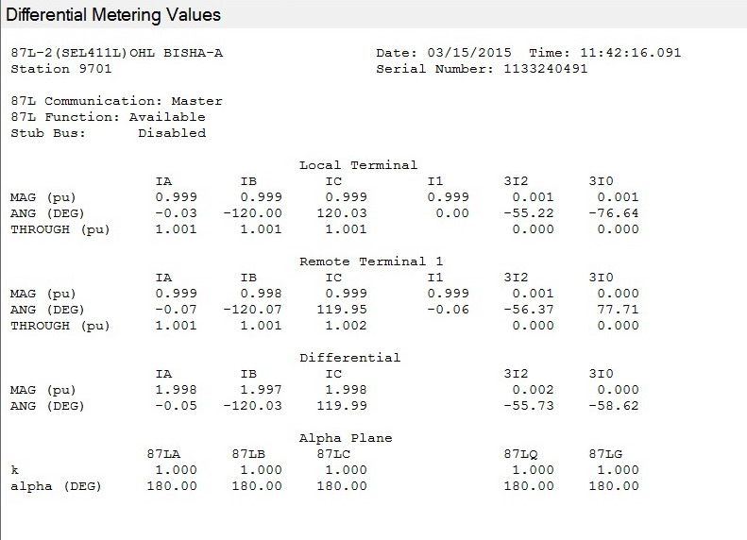

Current applied: 3PH, 1A

PTR: 380KV/115V CTR: 3000/1A

**CURRENT MEASUREMENT WITH ONLY CH 2:**

|  |  |  |  |  |  |  |  |
| --- | --- | --- | --- | --- | --- | --- | --- |
|  | PHASE A MAG/ ANG | PHASE B MAG/ ANG | PHASE C MAG/ ANG | 3I0  MAG/ ANG | | 3I2  MAG/ ANG | I1  MAG/ ANG |
| LOCAL | 0.998<-0.01 | 0.997<-120. | 0.997<120 | | 0<-73.58 | 0.002<-1.46 | 0.998<0 |
| CHANNEL 2 | 0.998<0.01 | 0.998<-120 | 0.997<120 | | 0.001<178.2 | 0.001<30.89 | 0.998<0 |
| Differential | 1.996<0 | 1.998<-120 | 1.998<120 | | - | - | - |
| Alpha | 1<180 | 1<180 | 1<180 | | - | - | - |

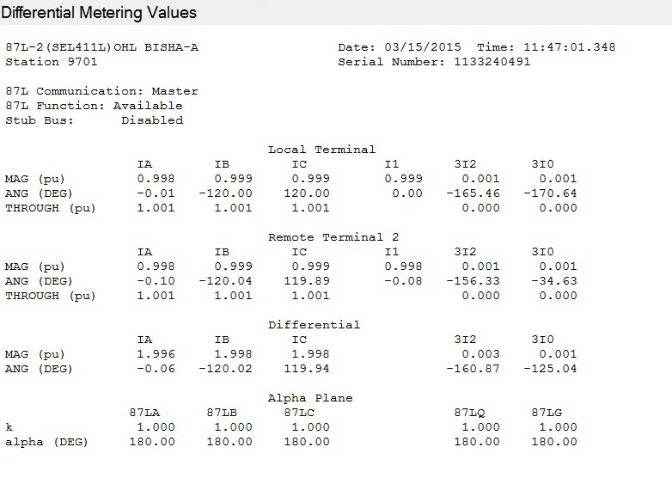

ALPHA VALUE:

Alpha is complex ratio between Remote current (IR) and local current (IL). It is represented with magnitude and angle.

### I.1. sensitivity and TIMING TEST: ( ONLY WITH CH-X)

Note:

* The sensitivity and timing tests are conducted with relay to relay.
* In LOOP BACK test the local current is routed as remote current. So, the relay would see differential current twice the injected local current and the Alpha Value would be always 1<0deg , which is ideal operating point in operating region of Alpha plane. So, the expected pickup current is 50% of the 87LPP/ 87L2P / 87LGP.

1. **SENSITIVITY TEST:**

Step1: Set ‘EOCTL’ =N, EDD=N, to avoid blocking of 87L2,87LG and blocking due to slow change in current.

Step2: Set 87L2P=OFF and 87LGP =OFF, while testing 87LP, Do the same while testing others.

Step3: Increase current on one phase until relay trips on 87. Repeat the same for other phases.

Step4: The appropriate Relay Word Bit shall be monitored on front panel or 5025 HMI.

1. Use the TEST 87L command to enter Test Mode

2. Ensure that relay outputs are supervised or isolated. See Test Precautions for details.

3. When prompted, select a characteristic test and single-terminal mode. Choose the element and normal or secure depending on the particular settings to be tested.

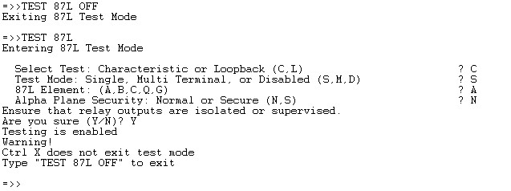

**PHASE CURRENT DIFFFERENTIAL:**

|  |  |  |  |  |  |  |  |  |  |  |
| --- | --- | --- | --- | --- | --- | --- | --- | --- | --- | --- |
| 87LPP | Expected pick up  87LPP | Phase A | | | Phase B | | | Phase C | | |
| P/U  (A) | HMI display Idiff = IAT  (secA) | D/O (A) | P/U (A) | HMI display Idiff = IBT  (sec A) | D/O (A) | P/U  (A) | HMI display Idiff = ICT  (sec A) | D/O (A) |
|  |  |  |  |  |  |  |  |  |  |  |

Pick up Accuracy: ±3% ±0.01 INOM, According to the Catalogue for manual # 20130311 Page 56

|  |  |  |  |  |  |  |  |  |  |  |
| --- | --- | --- | --- | --- | --- | --- | --- | --- | --- | --- |
| 87LPP | Expected pick up  87LPP | Phase A | | | Phase B | | | Phase C | | |
| P/U  (A) | HMI display Idiff = IAT  (secA) | D/O (A) | P/U (A) | HMI display Idiff = IBT  (sec A) | D/O (A) | P/U  (A) | HMI display Idiff = ICT  (sec A) | D/O (A) |
|  |  |  |  |  |  |  |  |  |  |  |

**NEGATIVE/ ZERO SEQ CURRENT DIFFERENTIAL:**

|  |  |  |  |  |  |  |  |
| --- | --- | --- | --- | --- | --- | --- | --- |
| 87L2P/ 87LGP | Expected pick up  87L2P or 87LGP | 87L2 –Negative seq diff | | | 87LG- zero seq diff | | |
| P/U (A) | HMI display Idiff= 3I2T  (pri A) | D/O (A) | P/U (A) | HMI display Idiff= 3I0T  (Pri A) | D/O (A) |
|  |  |  |  |  |  |  |  |

Note:

For 87L2 /87LG sensitivity a single phase current shall be injected. In this case the negative sequence (I2) or zero sequence (I0) current is equal to 1/3\* Iph. But the relay compares 3 x I2\_injected and 3 x I0\_injected with the 87L2P / 87LGP thresholds.

**TIMING TEST:**

SETTING:

87LPP: A 87L2P: A 87LGP: A

|  |  |  |  |
| --- | --- | --- | --- |
| PHASE | Inject current | Delay time | Operating time at  2x87LPP (msec) |
| A |  |  |  |
| B |  |  |  |
| C |  |  |  |

### **ALPHA PLANE RESTRAIN TEST:**

Note:

This test requires simultaneous current inject from time synchronized test kits, if the injection shall be performed at different location of local and remote relay.

**ALPHA ANGLE TEST:**

**SETTING:**

87LPP: 1.0A 87L2P: 0.1A 87LGP: 0.1A 87LR:2TST 87LANG:195 DEG

* Enable 87LPP and disable 87L2P and 87LGP for testing 87LP.
* Apply Phase A, local current and remote current as IR= 1A<0deg, IL=1A<0deg. With this current the relay would be operate region.
* Vary the phase angle of IR and note down relay operate region and restrain region.
* The same shall be done for other phases.

|  |  |  |  |
| --- | --- | --- | --- |
| Diff. element | IL angle (fixed) | IR angle at Relay operates | IR angle at Relay resets |
| 87LA | 0 |  |  |
| 87LB | 240 |  |  |
| 87LC | 120 |  |  |
| 87L2 | 0 |  |  |
| 87LG | 0 |  |  |

Accuracy: +/- 3° of angle setting, According to the Catalogue for manual Page 56

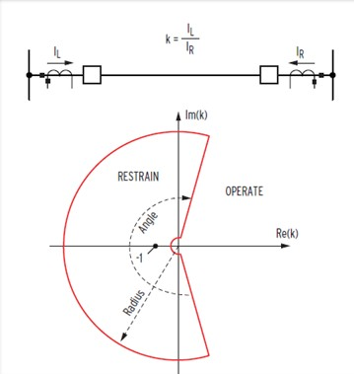

**Expected Restraining angle:**

Alpha angle = 180deg to 180-(87LANG/2)

Setting 87LANG=195deg,

Restraining angle = 180 to 82.5 deg, Operating angle = 82.5deg to 0deg

Accuracy: +/- 3deg .

**ALPHA RADIUS TEST:**

**SETTING:**

87LPP: 0.2 A 87L2P: 0.1A 87LGP: 0.1A 87LR:2 87LANG:195 DEG

* Apply local and remote current out of phase and equal magnitude.
* Increase the remote current magnitude by fixing local current until the relay trip to find the outer radius
* Increase the local current magnitude by fixing remote current until the relay trip to find the outer radius.

**ALPHA RADIUS MEASURED AT ALPHA ANGLE =180deg.**

|  |  |  |  |  |  |  |
| --- | --- | --- | --- | --- | --- | --- |
| Diff. element | RADIUS ODPERATION | | | RADIUS OPERATION | | |
| I Local (fixed)A | I Remote(A) | Radius(IL/IR) | I Remote (fixed) A | I Local (A) | Radius (IL/IR) |
| Operate | Operate |
| 87LA |  |  |  |  |  |  |
| 87LB |  |  |  |  |  |  |
| 87LC |  |  |  |  |  |  |
| 87L2 |  |  |  |  |  |  |
| 87LG |  |  |  |  |  |  |

Expected outer radius: 2

Accuracy: +/-5% setting as per instruction manual page 58.

1. **DISTANCE FUNCTION (21):**

* The SEL-411L has Five independent zones of mho phase distance protection.

All zones are independently set. Zones 1 and 2 are fixed to operate in the forward direction only. Zones

3, 4 and 5 can be set to operate in either the forward or reverse direction. The phase distance elements use positive sequence voltage polarization for security and to create an expanded mho characteristic. The phase distance elements operate on phase-to-phase, phase to phase to ground, and three-phase faults.

Note: For more details refer Instruction manual .

* Note: For more details refer Instruction manual page: 4.11

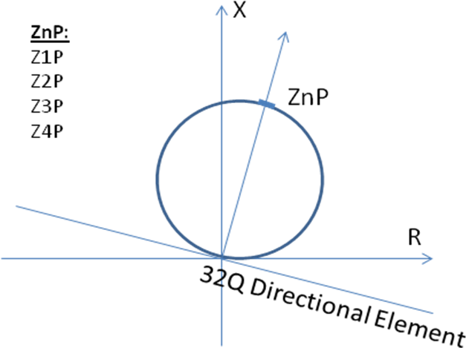

Figure 1: Phase/Ground Distance Elements (Mho characteristics)

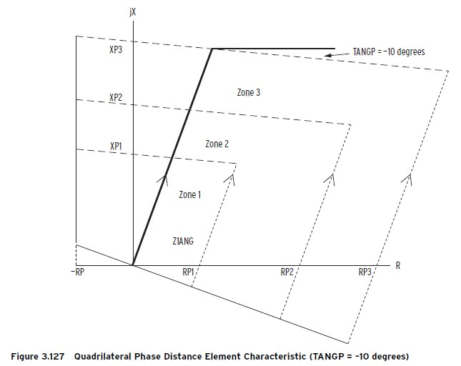

TANGP = –10 degrees. Notice that the reactance elements are tilted by

10 degrees, but the resistance blinders are unaffected by this setting. Also

notice that the pivot point of the tilt is the line impedance and not the reactance

axis. Furthermore, there are no individual TANGP settings for each zone;

when you enter a value other than zero for TANGP, all enabled zones are tilted

by the same value. Pa 294

1. **QUADRILATERAL GROUND DISTANCE ELEMENTS**

A common misconception is that the reach of the relay needs to be multiplied by the sine of the

line angle when testing the element at that angle. In actuality, the reach of the quad element is

exactly the same as the mho element, extending along Z1ANG as shown in Figure 3. Z1ANG is

also known as Maximum Torque Angle (MTA).

There is no setting for –RP, the left

Blinder; this value is fixed at the negative value of the lowest forward looking

Resistive RPn setting (n = 1–5). For example, if RP1 is set to RP1 = 3.8 , and

if RP1 is the minimum of RP1–RP5, then the left blinder setting becomes

–3.8 . Zones set to OFF (XPn = OFF). Pa -293

1. **DISTANCE FUNCTION CHECK:**

Note: DEF unit disabled for testing of distance unit.

* 1. **Phase-to-Phase Current Fault Detectors (Zones 1–4) :**

From setting file extract the Setting for Phase-to-Phase Current Fault Detectors (50PP1, 50PP2, 50PP3, 50PP4).

Normally the setting of the detectors are the same and as small as possible to detect the faults.

|  |  |  |
| --- | --- | --- |
| (50PP1, 50PP2, 50PP3, 50PP4).  setting | Phase | Pick up (A) |
| 0.1 A | R-Y |  |
| Y-B |  |
| B-R |  |
| RYB |  |

Accuracy is ±0.01 A and ±3% of setting (1 A nominal), refer to 311L manual page 4.7

Where (Z1P, Z2P, Z3P and Z4P) are the pickup phase elements for the zones (Z1, Z2, Z3, Z4) respectively.

Note: Z1, Z2 are always forward direction.

Z3 and Z4 are settable forward or reverse (The default setting: Z3 is reverse and Z4 is forward).

* For Ph-Ph detectors , the Pickup value will be half of the setting ph-ph current detectors.

**Test procedure:** Voltage of faulty phase is zero but for healthy phases is normal. Inject **Ph -Ph** fault current with angle 180 degree. Increase **for faulty phases** until P/U.

To show the required above targets refer to index (A) at the end of the test procedure. Z1PT

1. **PHASE-TO-GROUND CURRENT FAULT DETECTORS (ZONES 1–4) :**

From setting file extract the Setting for Phase-to-Ground Current Fault Detectors (50L1, 50L2, 50L3 & 50L4) and (50GZ1, 50GZ2, 50ZG3 & 50GZ4).

Where:

(50L1, 50L2, 50L3 & 50L4) are the pickup phase elements for the zones (Z1, Z2, Z3, Z4) respectively for the ground Mho characteristic.

and (50GZ1, 50GZ2, 50ZG3 & 50GZ4) are the pickup phase elements for the zones ( Z1,Z2,Z3,Z4) respectively for the ground Quadrilateral characteristic.

Normally the setting of the detectors are the same and as small as possible to detect the faults.

|  |  |  |
| --- | --- | --- |
| (50L1, 50L2, 50L3 & 50L4) and (50GZ1, 50GZ2, 50ZG3 & 50GZ4).  Setting | Phase | Pick up (A) |
| 0.1A | R-N |  |
| Y-N |  |
| B-N |  |

Accuracy is ±0.01 A and ±3% of setting (1 A nominal) , refer to 311L manual page 4.11

Where (Z1G, Z2G, Z3G and Z4G) are the pickup phase elements for the zones (Z1, Z2, Z3, Z4) respectively for the mho and/or quad. Distance elements.

1. **IMPEDANCE REACHES CHECK:**

To get a proper reach test results for ground fault quadrilateral elements, Prefer to use constant source impedance model (to be able to simulate the actual system change for the magnitude and the angle of both of the voltages and the currents to reach the required impedance point)

|  |  |  |
| --- | --- | --- |
| **Item** | **Description** | **Checked** |
| 1 | Print out from Test Kit attached | Ok |

Impedance tolerance: +/- 5% ,refer Instruction manual page: 1.10

**OPERATING TIME TESTING:**

|  |  |  |
| --- | --- | --- |
| **Item** | **Description** | **Checked** |
| 1 | Print out from Test Kit attached | Ok |

Timer Accuracy is ±0.25 cycle and ±0.1% of setting, refer to Instruction manual page: 4.20

**NOTE :**  IN 3 PHASE FAULT R(reach) = R(setting)/4 but in actual it operate after 55 degree

1. **DIRECTIONALTEST:**

**Note: The directionality test in SEL-311L relays is not using the traditional directional positive sequence polarized voltage algorithm. SEL-311L depends on the negative sequence impedance (Z2) to determine the directionality (forward or reverse). Based on that the directionality is changing dynamically based on the negative sequence voltage (V2) and negative sequence current (I2).**

**So, The test of the directional line is not required because it is not easy to be done by the secondary test kits , you can test one point as per the steps down.**

**Checking the Negative-Sequence Directional Element (32Q):**

The SEL-311L calculates the negative-sequence impedance Z2c from the magnitudes and angles of the negative-sequence voltage and current. (the ‘c’ in Z2c indicates “calculated”).

****

where:

V2 = the negative-sequence voltage

I2 = the negative-sequence current

Z1ANG = the positive-sequence line impedance angle

Re = the real part of the term in brackets, for example,(Re[A + jB] = A)

\* = the complex conjugate of the expression in parentheses,(A + jB)\* = (A – jB)



Note: - for more details about the negative seq. impedance characteristic , please refer to (paper: NEGATIVE-SEQUENCE IMPEDANCE DIRECTIONAL ELEMENT, Bill Fleming Schweitzer Engineering Laboratories, Inc. Pullman, WA USA ).

**Test Current:**

From the above equation the test current values that you need to apply to the relay to test the element. For the negative sequence current I2, the result is:



Multiply the quantities in **I2**by three to obtain **3I2**, the negative sequence current that the relay processes. With a fixed applied negative sequence voltage VA, the relay negative sequence voltage is 3V2.

Set Z2c = Z2F to find the test current magnitude at the point where the impedance calculation equals the forward fault impedance threshold.

- Then the forward impedance fault current is



When :



- For a reverse fault impedance threshold, where Z2c = Z2R, then the reverse impedance fault current is :



When the angle :



This test confirms operation of the **F32Q** and the **R32Q** negative-sequence directional elements.

Where :

**F32Q** : Forward negative-sequence voltage-polarized directional element

**R32Q**: Reverse negative-sequence voltage-polarized directional element

**Z2F**: Forward Directional Z2 Threshold

**Z2R**:Reverse Directional Z2 Threshold

**Note: when Z2F and Z2R Set Automatically**

If configuration setting E32 = AUTO, settings Z2F and Z2R (negative sequence impedance values) are calculated automatically, using the positive sequence line impedance magnitude setting Z1MAG as follows:

Z2F = **Z1MAG/2** (Ohm secondary)

Z2R = **Z1MAG/2 + 0.1** (Ohm secondary; 5A nominal)

Z2R = **Z1MAG/2 + 0.5** (Ohm secondary; 1A nominal)

Where: Z1MAG is the protective line positive sequence impedance

The Z2c is equivalent to Z2MEASURED. The criteria for declaring forward and reverse fault

conditions are:

• z2 < Z2F threshold: Forward fault condition

• z2 > Z2R threshold : Reverse fault condition

1. **TEST PROCEDURE OF THE DIRECTIONAL ELEMENT FOR PHASE FAULTS (UNSYMMETRICAL FAULTS):**

* Using AcSELerator QuickSet software , Do the following:

- Confirm that **ELOP (If It is Enabled)** is set to **N** .

- **Load Encroachment (If It is Enabled and can affect the test)**, and confirm that **ELOAD** is

set to **N**.

- Be sure that the relay seeing the CB closed continuously (52a asserted).

- Confirm the following settings: **E32** is **AUTO**, **ORDER** is **QV.**

**-** Display the F32Q and R32Q .

- Calculate impedance thresholds:

a. For example, apply an A-phase voltage of VA = 3V2 = 20.0 ∠180º V secondary (other phase voltages VB and VC will be zero volts ).

b. Use the previous mentioned equation to find the current that is equal to the reverse impedance threshold Z2R and Z2F threshold :

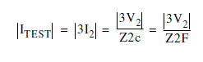

From the setting file :

Z2f = 9.92 Ohms

Z2R = 10.42 Ohms

Expected operating current for direction function:

* I Test ( forward) = 20 / 9.92 = 2.016 A
* I Test ( reverse) = 20 / 10.42 = 1.919 A
* The angle for both (I Test ( forward)) & (I Test ( reverse)) = 180 – 79.45 = 100.55º
* Connect a single current test source
* Set the current source for IA = 0.0 ∠ 100.55° A.
* Slowly increase the magnitude of IA to apply the source test current.
* Using AcSELerator QuickSet software /HMI/Device Overview, Monitor the status of R32Q and F32Q signals.
* Observe the Relay Word bit **R32Q** asserts when |IA| = 0.1 A, indicating that the relay negative-sequence current is greater than the **50RP** pickup threshold.**R32Q** desserts when |IA| = 1.919 A, indicating that the relay negative-sequence calculation Z2c is now less than the Z2 reverse threshold Z2R
* Continue to increase the current source while you observe the Relay Word bit **F32Q** asserts when |IA| = 2.016 A, indicating that the relay negative-sequence calculationZ2c is less than the Z2 forward threshold Z2F.

|  |  |  |  |  |
| --- | --- | --- | --- | --- |
| **Setting** | **Expected operating current** | **Injected Voltage** | **Directional**  **Status** | **WORD BIT** |
| FORWARD NEGATIVE SEQUENCE IMPEDANCE Z2F =9.92 ohm | For forward direction ≥ 2.016 A ∠100 º | VA=20∠180º , VB=VC= Zero |  | F32Q |
| For forward direction ≥ 1.209A ∠100 º | VA=12∠180º , VB=VC= Zero |  | F32Q |
| For forward direction ≥ 0.604A ∠100 º | VA=6∠180º , VB=VC= Zero |  | F32Q |
| For forward direction ≥ 0.201A ∠100 º | VA=2∠180º , VB=VC= Zero |  | F32Q |
| REVERSE NEGATIVE SEQUENCE IMPEDANCE Z2R = 10.42 ohm | For reverse direction ≤ 1.919A∠100 º | VA=20∠180º , VB=VC= Zero |  | R32Q |
| For reverse direction ≤ 1.15A∠100 º | VA=12∠180º , VB=VC= Zero |  | R32Q |
| For reverse direction ≤ 0.575A∠100 º | VA=6∠180º , VB=VC= Zero |  | R32Q |
| For reverse direction ≤ 0.1919A∠100 º | VA=2∠180º , VB=VC= Zero |  | R32Q |

1. **POWER SWING BLOCKING TEST:**

- If a three-phase fault occurs during a power swing that has operated the OOS logic, the logic also overrides OOS blocking; a set of internally derived inner blinders encompasses the protected line and detects internal three-phase faults.

- If the breaker open, simulate (52A = 1) status closed or inject current more than 0.05 A to desert open pole logic, else out of step function will be blocked.

- For power swing test apply three phase voltages and 3 phase currents to the relay.

The reactance reaches of Z6& Z7 are perpendicular on the protective line angle.

The Resistive reaches of Z6 & Z7 are parallel to the protective line angle.

For test purposes we need to assign the following signals to output contacts to check the reaches of the Out Of Step characteristic

X6ABC: Zone 6, out-of-step distance element, instantaneous

X7ABC: Zone 7, out-of-step distance element, instantaneous

1. **Out of Step Impedance Reach Test:**

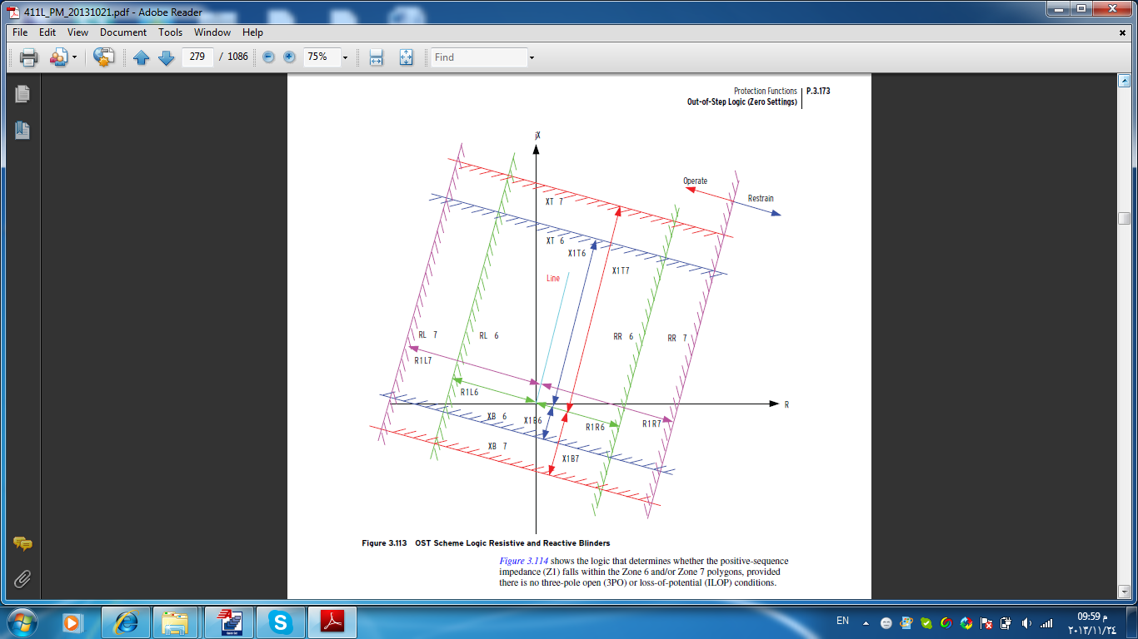

|  |  |  |
| --- | --- | --- |
| Item | Description | Checked |
| 1 | Print out from Test Kit attached | OK |

Characteristic Accuracy: ±5% of setting plus ±0.05 A for SIR (source to line impedance ratio) < 30

±10% of setting plus ±0.05 A for 30 < SIR < 60

According to the Catalogue for Instruction manual # 20130311 Page 60

1. **Out of Step Blocking:**

* To test Z1, Z2 (Froward zone), Apply impedance point outside Z7 in the 1st quarter.
* Apply impedance point inside the area between Z7 and Z6 for more than the Out-of-Step Block Time Delay setting (OSBD). Check that OSB signal appeared after the OSBD setting time.
* Apply impedance point inside the Z2 for duration less than 2 sec and check that the relays didn’t trip.
* Repeat the same for the other zones by applying impedance point inside Z2, Z1 directly after the impedance point in the area between Z7 and Z6.

|  |  |  |
| --- | --- | --- |
| **Distance Zone** | **Out of step blocking test** | **Result** |
| 1 | Z1 Trip after OSB Reset time = sec |  |
| 2 | Z2 Trip after OSB Reset time = sec |  |
| 3 | Z3 Trip after OSB Reset time = sec |  |
| 4 | Z4 Trip after OSB Reset time = sec |  |
| 5 | Z4 Trip after OSB Reset time = sec |  |

Measurement of the OSB reset time blocking time (Fixed 2 sec) = 2.0Sec.

1. **VTS FUNCTION TEST (LOSS OF POTENTIAL):**



Inputs into the LOP logic are:

- 3PO three-pole open condition (indicates circuit breaker open condition)

- V1 positive-sequence voltage (V secondary)

- I1 positive-sequence current (A secondary)

- V0 zero-sequence voltage (V secondary)

- I0 zero-sequence current (A secondary)

- V2 negative-sequence voltage (V secondary)

Figure 4: Loss of Potential Logic (LOP)

Operation Philosophy for LOP Logic:

The circuit breaker has to be closed (Relay Word bit 3PO = logical 0) for the LOP logic to operate.

Loss-of-potential is declared (Relay Word bit LOP = logical 1) when a 10 percent drop in V1 is detected, with no corresponding change in I1 or I0. If the LOP condition persists for 60 cycles, it latches in. LOP resets (Relay Word bit LOP = logical 0) when all three of the phase voltages return above 40 V secondary, V0 is less than 5 V secondary, and V2 is less than 15 percent of V1.

Note: **if setting ELOP = Y and a loss-of-potential condition occurs** (Relay Word bit LOP asserts to logical 1), overcurrent elements set direction forward are enabled (from the 411L manual see *Figure 4.47*). These **direction** forward overcurrent elements effectively **become non-directional** and provide overcurrent protection during a loss-of-potential condition.

Note : The VT MCB contact is not available as part from the LOP algorithm , but we can use the opto-input of the VT MCB to create blocking for the tripping output contacts for the protection functions which depends on the voltage.

For example: Out205 =! IN307\*(Z1T+Z2T+Z3T+Z4T) , that equation means if the IN307 asserted then the output contact 205 will not operate for any zone trip.

Or write function in automation 1 and take final variable on output contact for example

ASV001:= IN207

AMV001:= 1.000000

ASV010:= LOP

ASV002:= 67P1T OR 67P2T OR 67P3T OR 67P4T OR 67Q1T OR 67Q2T OR 67Q3T OR 67Q4T

# O.C TIME DELAY

ASV003:= Z1T OR Z2T OR Z3T OR Z4T OR Z5T #ALL ZONE TIME DELAY

ASV004:= ASV003 AND NOT ASV001

ASV005:= ASV004 OR ASV002

**Note by using Binary input must be disable for general trip.**

1. **LOSS OF POTENTIAL TEST FOR LOSS OF ONE, TWO OR THREE PHASES**:

- CB status should be seen by the SEL-411L relay as closed to avoid the blocking of the open pole logic for the LOP function

- Apply 3 Phase rated voltage (Ur V) with balanced angles.

- Apply 3 Phase rated current (Ir A) with balanced angles.

- Within one step remove the voltage on one phase and / or two phases .

- Repeat the same by removing three phase voltages

.

Note: To reset LOP signal, you have to inject phase voltages return above 40 V secondary on the three phases.

|  |  |  |  |  |
| --- | --- | --- | --- | --- |
| PHASE UNDER TEST | Applied balance Voltage | Applied Balance Current | Voltage lost | Result |
| A | 66.4V | 1 | A | ok |
| B | 66.4V | 1 | B | ok |
| C | 66.4V | 1 | C | ok |
| A,B,C | 66.4V | 1 | A,B,C | ok |

1. **SWITCH ON TO FAULT (SOTF) :**

Switch-Onto-Fault (SOTF) trip logic provides a programmable time window for selected elements to trip right after the circuit breaker closes. “Switch on to fault” implies that a circuit breaker is closed into an existing fault condition,

Refer to the switch-onto-fault trip logic in the 311L manual *Figure 5.7* (middle of figure). The SOTF trip logic permits tripping if both the following occur:

* An element asserts in SELOGIC control equation trip setting TRSOTF
* Relay Word bit SOTFE is asserted to logical 1

SOTF Initiation:

The relay validates an SOTF condition by sensing the following:

* **Upon circuit breaker opening**: detection of a pole open condition (3PO) when setting 52AEND (52A Pole Open Qualifying Time Delay) is other than OFF
* **Upon circuit breaker closing**: detection of a pole open condition (3PO) when setting CLOEND (Close Enable Time Delay) is other than OFF.

Circuit breaker operated switch-onto-fault logic is enabled by making time setting 52AEND (52AEND = OFF). Time setting 52AEND qualifies the three-pole open (3PO) condition and then asserts Relay Word bit SOTFE: SOTFE = **logical 1**

Open pole (3PO) depends on monitoring CB status (52A) and current is below phase pickup 50LP (50L = logical 0).

Note that SOTFE is asserted when the circuit breaker is open. This allows elements set in the SELOGIC control equation trip setting TRSOTF to operate if a fault occurs when the circuit breaker is open (see 311L manual *Figure 5.7*).

When the circuit breaker is closed, the 3PO condition dessert (3PO = logical 0) after the 3POD dropout time (setting 3POD is usually set for no more than a cycle). The SOTF logic output, SOTFE, continues to remain asserted at logical 1 for dropout time SOTFD time.

Relay Word bit SOTFE is the output of the circuit breaker operated SOTF logic or the close bus operated SOTF logic described previously. Time setting SOTFD in each of these logic paths provides the effective time window for the instantaneous elements in SELOGIC control equation trip setting TRSOTF to trip after the circuit breaker closes (see *Figure 5.7*, middle of figure from 311L manual). Time setting SOTFD is usually set around 30 cycles.

An instantaneous element is usually set to trip in the SELOGIC control equation trip setting TRSOTF (e.g., TRSOTF = M2P + Z2G + 50P1).

**Note**: If the voltage potential for the relay is from the line-side of the circuit breaker, the instantaneous overcurrent element in the SELOGIC control equation trip setting TRSOTF should be non-directional. When the circuit breaker is open and the line is de-energized, the relay sees zero voltage. If a close-in three phase fault condition exists on the line (e.g., safety grounds accidentally left attached to the line after a clearance) and then the circuit breaker is closed, the relay continues to see zero voltage. The directional elements have no voltage for reference and cannot operate. In this case, the instantaneous overcurrent element in the SOTF trip logic should be non-directional.

**Close Signal Monitor (Manual close command):**

Assign the Relay Word bit CLSMON to a control input, so the relay can detect execution of the close command. Connect IN308 in parallel with the circuit breaker close coil.

CLSMON: = **IN308** Close Signal Monitor (SELOGIC Equation)

**SOTF settings:**

* **Inside setting file /Group 1/Set 1/Switch-Onto-Fault :**

ESOTF = Y

CLOEND (CB close enable time delay) = 10 Cycles

52AEND ( the required time to open the CB poles and confirm that CB opened) =10 cycles

SOTFD (The time which the SOTF will reset after closing the CB) = 30 Cycles

* **Inside setting file /Group 1/Logic 1/(Trip/Comm.- assisted trip logic ) :**

TRSOTF = M2P+Z2G+50P1

* **Inside setting file /Group 1/Logic 1/Other Equations/CLMON :**

**CLMON = IN204**

* 1. **SOTF initiated by Manual CB close**:

Insert the following settings:

ESOTF = Y

CLOEND (CB close enable time delay) = 10 cycles

SOTF function not work by m/c only if relay see the CB open pole before m/c signal by CLOEND tiMe

52AEND ( the required time to open the CB poles and confirm that CB opened) = off

SOTFD (The time which the SOTF will reset after closing the CB)= 30 Cycles

( assign SOTF tripping equation to zone 2 as described above)

simulate 2 stages; stage 1: simulate CB open (No current and voltages) , stage 2: fault case within Z1,Z2 and close up fault ( no voltages, 50P1 will trip instantaneously). at stage1 give manual close pulse ( IN308) for sufficient duration after CLOEND timer setting.

|  |  |
| --- | --- |
| SOTF IN | Measured Time (m sec) |
| Zone 1 | 18.1 |
| Zone 2 | 18.7 |

**SOTFD (The time which the SOTF will reset after closing the CB)**

|  |  |  |
| --- | --- | --- |
| Setting | Calculated value  ( sec) | Measured Time (sec) |
| 30 Cycles | 0.5 | 0.484 |

1. **AIDED (21) BLOCKING SCHEME :**

**TIMER SETTINGS**

* Z3XPU–Zone (Level) 3 Reverse Pickup Time Delay

Current-reversal guard pickup timer—typically set at 2 cycles.

* Z3XD–Zone (Level) 3 Reverse Dropout Extension

Current-reversal guard dropout timer—typically set at 5 cycles.

* BTXD–Block Trip Receive Extension

Sets reset time of block trip received condition (BTX) after the reset of block trip input BT.

* 21SD and 67SD–Zone 2 Short Delay

Carrier coordination delays for the output of Zone 2 overreaching distance

Elements 21SD and 67SD are typically set at 1 to 2 cycles.

1. The communication scheme is common for 21 and 67G.
2. DCB scheme accelerates 21 – zone2 and 67G- level2 to with carrier co-ordination time.

For 21, it is 21SD – short delay and for 67G, it is 67SD short delay.

1. DCB scheme send Block signal DSTRT, when 21- zone3 or 67 – level3 starts. This signal includes current reversal timer.

The current reversal timers Z3XPU (CR pickup delay, typically 2 cyc), Z3XD (CR drop off delay, typically 5 cyc).

1. DCB scheme has Block trip input (channel/ block receive) in SELogic equation, BT = (IN301+! IN103)+(IN302+!IN104),In this equation the inputs shall be assigned that wired to CR for 21 and 67G, if they have independent channels.

BT output has an OFF-time delayed output BTX from off-delay timer BTXD (Block trip receive extension). The BTX is used to block instant trip from 21-Zone2 and 67G-level2. The BTXD shall be set zero if you have already set Z3XD as CR timer at remote end.

1. The comm.-assisted trip shall be TRCOMM = Z2PGS + 67QG2S, these elements includes the carrier coordination delay.
   1. **DISTANCE COMM. SCHEME TEST:**

**DCB Scheme:**

CHANNEL Send test:

- Apply zone3 fault and record the operating time of CS contact.

DSTRT operating time = 32.8 m.sec

Current Reversal timer:

Apply zone3 fault for duration less than Z3XPU and remove the fault. Then measure reset time of CS contact. It shall reset instantly.

Inject from freja 2 stages 1st stage Z3 fault and 2nd stage healthy condition

|  |  |
| --- | --- |
| SETTING (CYCLE) | 1 |
| RESULT (ms) |  |

Apply zone3 fault for duration just greater than Z3XPU and remove the fault. Then measure reset time of CS contact. It shall reset after Z3XD time delay.

|  |  |
| --- | --- |
| SETTING (CYCLE) | 6 |
| RESULT (ms) |  |

**POTT Scheme:**

COMM trip test:

TRCOMM =: (Z2P OR Z2G) AND IN204 # INPUT 204 IS CONFIGER CR

PLT02 =PUSHPOTTOM FOR COMM ENABLE

TR1 =: (Z2P OR Z2G) AND IN204

- Apply zone2 fault without CR and channel unhealthy. It shall trip with zone2 time.

Tripping time = 521 m.sec

LED indication = NO Comm. indication

- Apply zone2 fault with CR and channel unhealthy. It shall trip with zone1 time. .

Tripping time = 28.5 m.sec

LED indication = Comm. indication

-check signal send

Apply configuration for output contact

OUT204 =: (KEY AND PLT02 AND PLT04) # KEY SEND

1. **FAULT LOCATOR:**

Length = Km

Line Impedance = Ω

Results for Distance Relay:

|  |  |  |  |  |  |
| --- | --- | --- | --- | --- | --- |
| Item | Fault Type | Distance to Fault | Relay Fault Location Km | | Remarks |
| Expected | Actual |
| 1 | R-N | 25% Line Length |  |  |  |
| 2 | Y-B | 25% Line Length |  |  |  |
| 3 | B-N | 25% Line Length |  |  |  |
| 4 | R-Y | 50% Line Length |  |  |  |
| 5 | Y-N | 50% Line Length |  |  |  |
| 6 | R-B | 75% Line Length |  |  |  |
| 7 | R-Y | 75% Line Length |  |  |  |
| 8 | Y-B | 100% Line Length |  |  |  |
| 9 | R-Y-B | 100% Line Length |  |  |  |